**DATABASE DESGIN**

**&**

**DEVELOPMENT**

**Pet Care and Accessory Store**

**BY**

**Htet Htet**

**Sep, 2020**

Table of Contents

Chapter 1 4

Initial Design 4

1.1 Entity Relationship Diagram 4

1.2 Third Normal Form 5

1.3 Data Dictionary 7

Chapter 2 12

Database Implementation 12

2.1 Creating database and tables 12

2.2 Altering Table 20

2.3 Inserting Data to Tables 21

Chapter 3 30

Data Retrieval 30

3.1 Display vaccine name, type and price that is the most service in this pet care clinic 30

3.2 Display Spa Services detail that are served by pet name 'Minet' and 'Mickey' 30

3.3 Retrieve daily income in Pet Spa Service 31

3.4 Retrieve total spa service income in June 31

3.5 Retrieve total spa service income in 2020 32

3.6 Retrieve all vaccine detail record of pet 'Minet' 32

3.7 Retrieve all treatment record from start date '2019-06-01' to end date '2019-10-31' 32

3.8 Retrieve medical treatment record detail list of pet clinic with the corresponding pet id and pet name 33

3.9 Display monthly income in medical treatment 33

3.10 Display annual income in medical treatment 34

3.11 Retrieve top 5 best-selling product List 35

3.12 Retrieve product name and quantity in each product category 35

3.13 Retrieve product name and quantity in each product category 36

3.14 Retrieve daily income of customer sale product 36

3.15 Retrieve the best-selling month in 2020 37

3.16 Retrieve the best-selling product in January 37

3.17 Retrieve product purchase detail of customer id ‘9’ in Customer sale table 38

3.18 Display monthly income in Customer sale product in 2020 38

3.19 Display annual income in Customer sale product 39

3.20 Retrieve pet id and pet name which make spa service price greater than ‘50000 MMK’. 40

# Chapter 1

# Initial Design

## 1.1 Entity Relationship Diagram

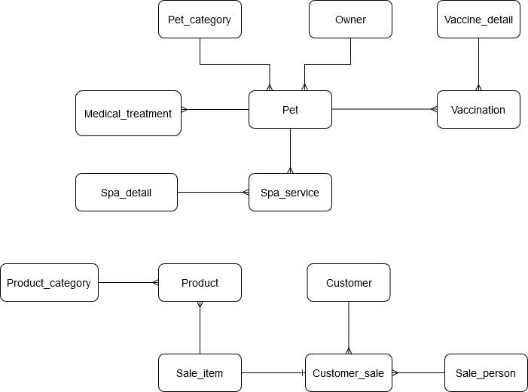

**Fig. 1.1 Entity Relationship Diagram**

## 1.2 Third Normal Form

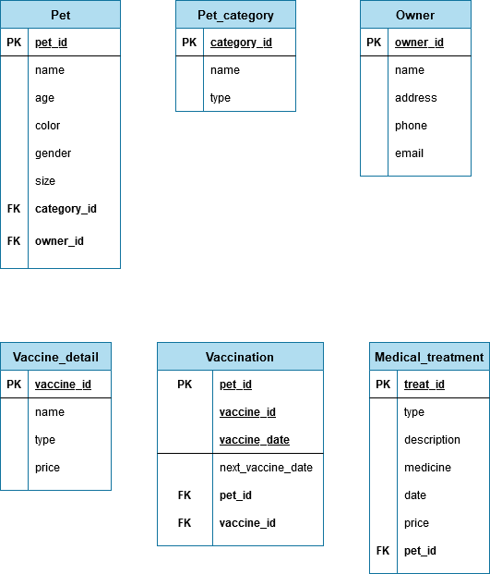

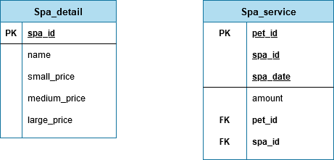

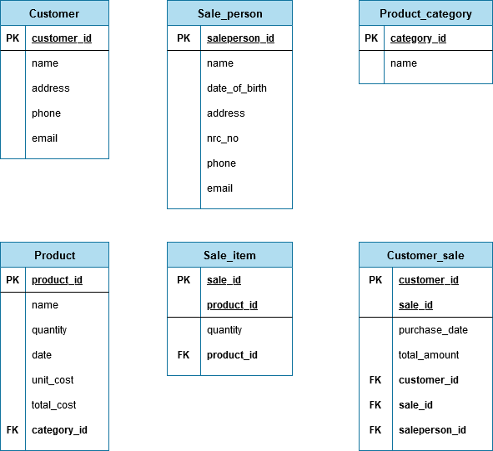

## 1.3 Data Dictionary

|  |  |
| --- | --- |
| Pet Table | |
| Entity Name | Pet |
| Primary Key | pet_id INT(16) AUTO INCREMENT |
| Foreign Key | category_id(*) INT(16) |
| owner_id(*) INT(16) |
| Other Attributes | name VARCHAR(25) |
| age INT(2) |
| color VARCHAR(15) |
| gender VARCHAR(10) |
| size VARCHAR(10) |

|  |  |
| --- | --- |
| Pet_category Table | |
| Entity Name | Pet_category |
| Primary Key | category_id INT(16) AUTO INCREMENT |
| Other Attributes | name VARCHAR(20) |
| type VARCHAR(10) |

|  |  |
| --- | --- |
| Owner Table | |
| Entity Name | Owner |
| Primary Key | owner_id INT(16) AUTO INCREMENT |
| Other Attributes | name VARCHAR(30) |
| address VARCHAR(200) |
| phone VARCHAR(15) |
| email VARCHAR(50) |
| Vaccine_detail Table | |
| Entity Name | Vaccine_detail |
| Primary Key | vaccine_id INT(16) AUTO INCREMENT |
| Other Attributes | name VARCHAR(50) |
| type VARCHAR(20) |
| price DECIMAL(15,2) |

|  |  |
| --- | --- |
| Vaccination Table | |
| Entity Name | Vaccination |
| Primary Key | pet_id INT(16)  vaccine_id INT(16)  vaccination_date DATE |
| Foreign Key | pet_id(*) INT(16)  vaccine_id(*) INT(16) |
| Other attributes | next_vaccination_date DATE |

|  |  |
| --- | --- |
| Medical_treatment Table | |
| Entity Name | Medical_treatment |
|  |  |
| Primary Key | treat_id INT(16) AUTO INCREMENT |
| Foreign Key | pet_id(*) INT(16) |
| Other Attributes | type VARCHAR(30) |
| description VARCHAR(200) |
| medicine VARCHAR(100) |
| date DATE |
| price DECIMAL(15,2) |

|  |  |
| --- | --- |
| Spa_detail Table | |
| Entity Name | Spa_detail |
| Primary Key | spa_id INT(16) |
| Other Attributes | name VARCHAR(30) |
| small_price DECIMAL(15,2) |
| medium_price DECIMAL(15,2) |
| large_price DECIMAL(15,2) |

|  |  |
| --- | --- |
| Spa_service Table | |
| Entity Name | Spa_service |
| Primary Key | pet_id INT(16)  spa_id INT(16)  spa_date DATE |
| Foreign Key | pet_id(*) INT(16)  spa_id(*) INT(16) |
| Other Attributes | amount DECIMAL(15,2) |

|  |  |
| --- | --- |
| Customer Table | |
| Entity Name | Customer |
| Primary Key | customer_id INT(16) |
| Other Attributes | name VARCHAR(30) |
| address VARCHAR(200) |
| phone VARCHAR(15) |
| email VARCHAR(50) |

|  |  |
| --- | --- |
| Sale_person Table | |
| Entity Name | Sale_person |
| Primary Key | saleperson_id INT(16) |
| Other Attributes | name VARCHAR(30) |
| date_of_birth DATE |
| address VARCHAR(200) |
| phone VARCHAR(15) |
| email VARCHAR(50) |

|  |  |
| --- | --- |
| Product Table | |
| Entity Name | Product |
| Primary Key | product_id INT(16) |
| Foreign Key | category_id(*) INT(16) |
| Other Attributes | name VARCHAR(30) |
| quantity INT(5) |
| date DATE |
| unit_cost DECIMAL(15,2) |
| total_cost DECIMAL(15,2) |

|  |  |
| --- | --- |
| Product_category Table | |
| Entity Name | Product_category |
| Primary Key | category_id INT(16) |
| Other Attributes | name VARCHAR(20) |

|  |  |
| --- | --- |
| Sale_item Table | |
| Entity Name | Sale_item |
| Primary Key | sale_id INT(16)  product_id INT(16) |
| Foreign Key | product_id(*) INT(16) |
| Other Attributes | quantity INT(4) |

|  |  |
| --- | --- |
| Customer_sale Table | |
| Entity Name | Customer_sale |
| Primary Key | customer_id INT(16)  sale_id INT(16) |
| Foreign Key | customer_id(*) INT(16)  sale_id(*) INT(16)  saleperson_id(*) INT(16) |
| Other Attributes | purchase_date DATE |
| total_amount DECIMAL(15,2) |

# Chapter 2

# Database Implementation

## 2.1 Creating database and tables

**1. Create petcare database**

CREATE petcare;

USE petcate;

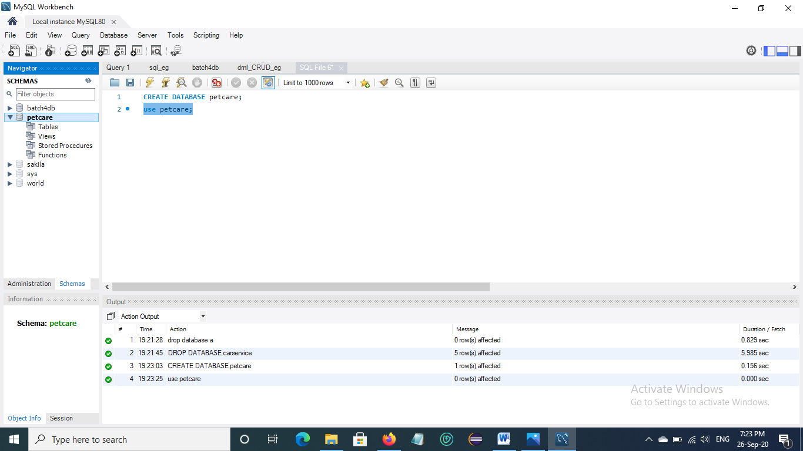

Fig. 2.1 Create petcare database

**2. Create Pet_category table**

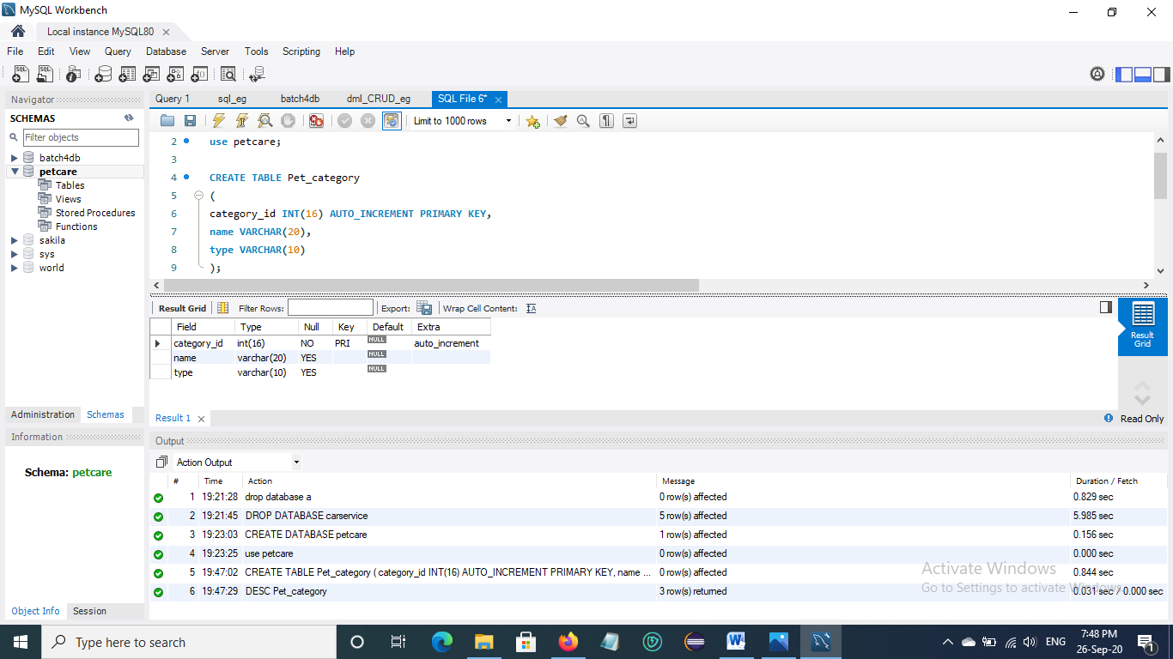

Fig. 2.2 Create Pet_category table

**3. Create Owner table**

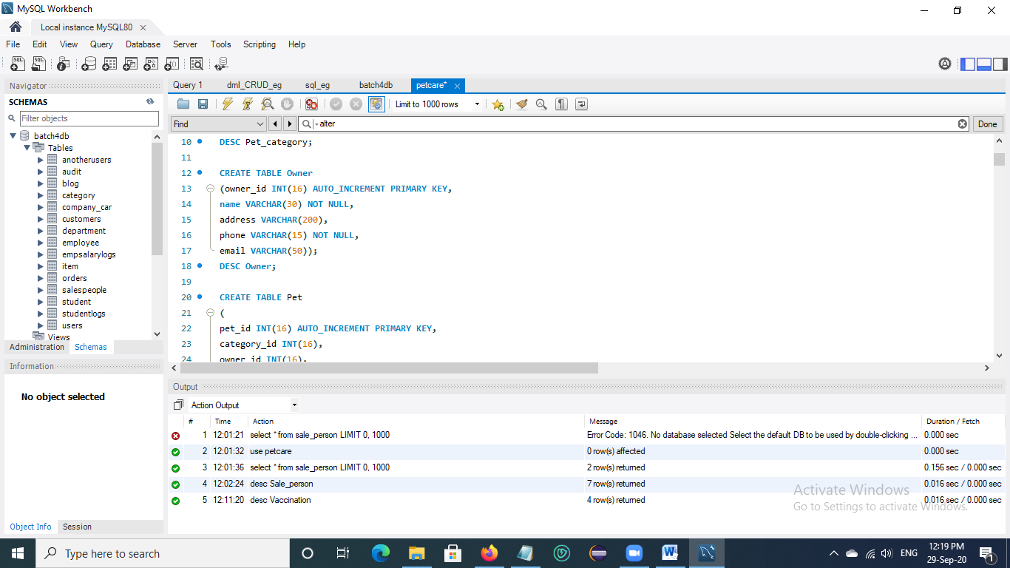

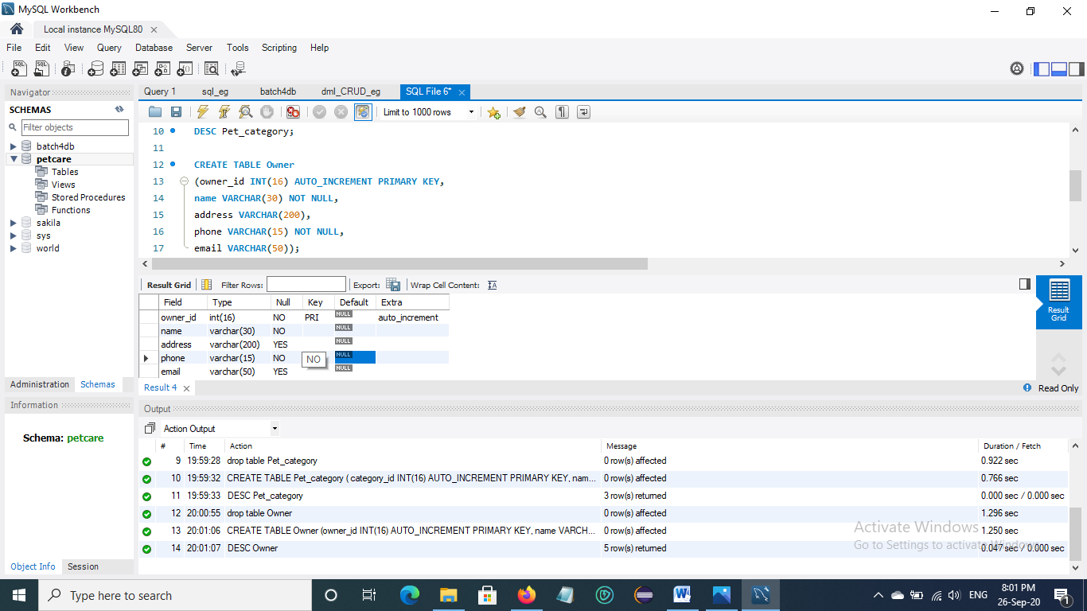

Fig. 2.3 Create Owner table

**4. Create Pet table**

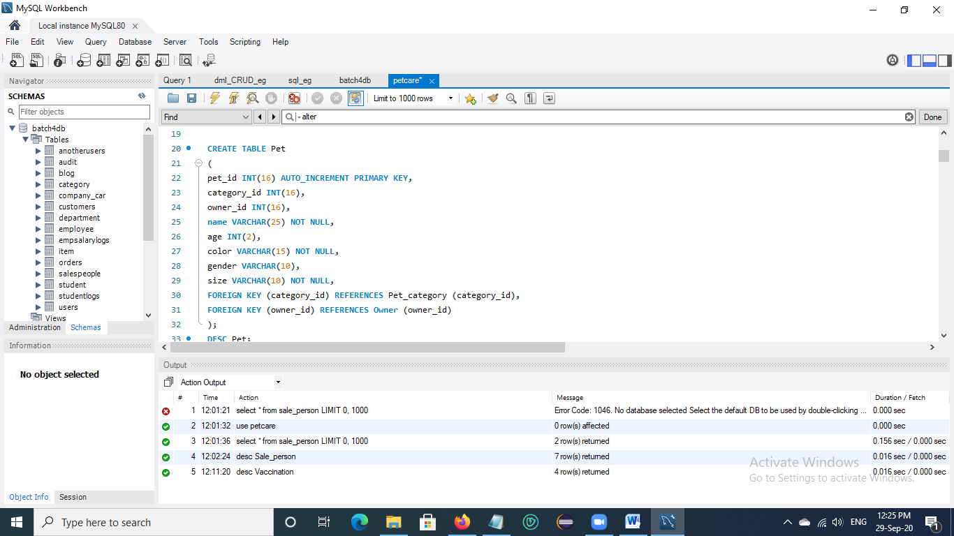

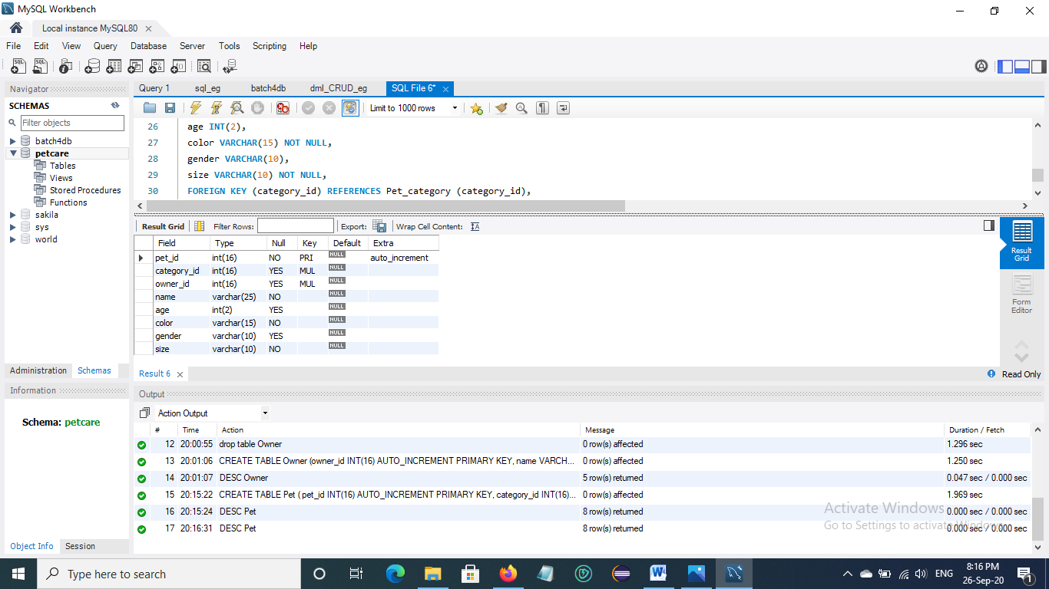

Fig. 2.4 Create Pet table

**5. Create Vaccine_detail table**

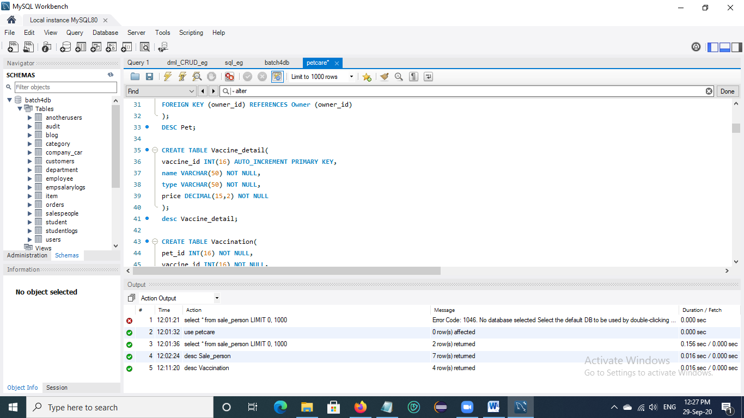

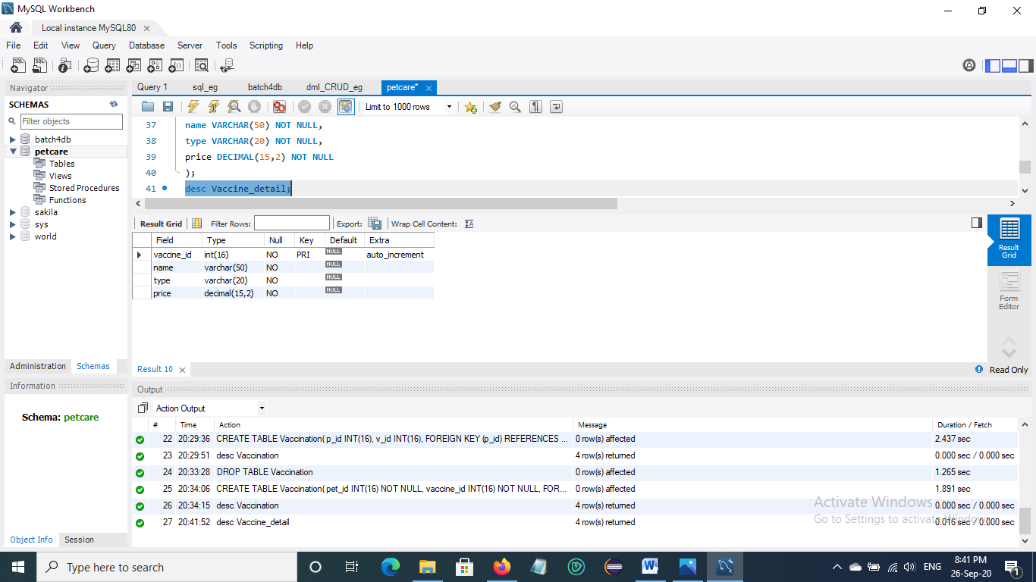

Fig. 2.5 Create Vaccine_detail table

**6. Create Vaccination table**

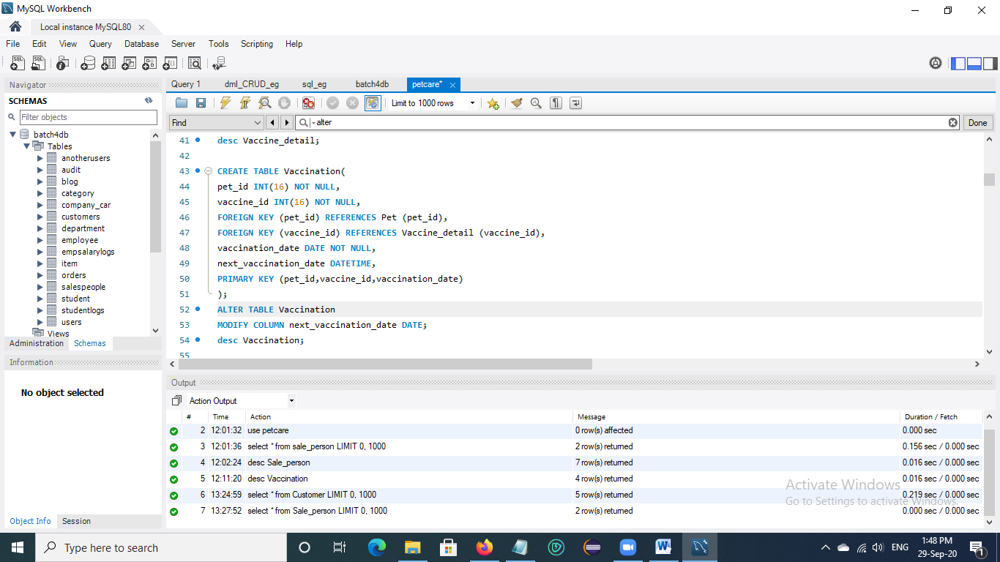

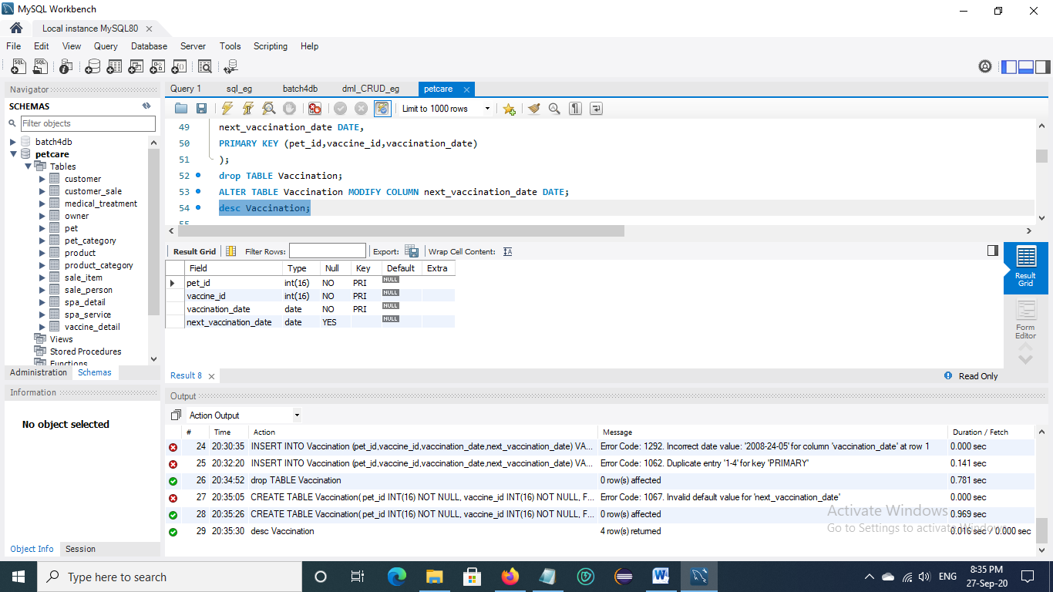

Fig. 2.6 Create Vaccination table

**7. Create Medical_treatment table**

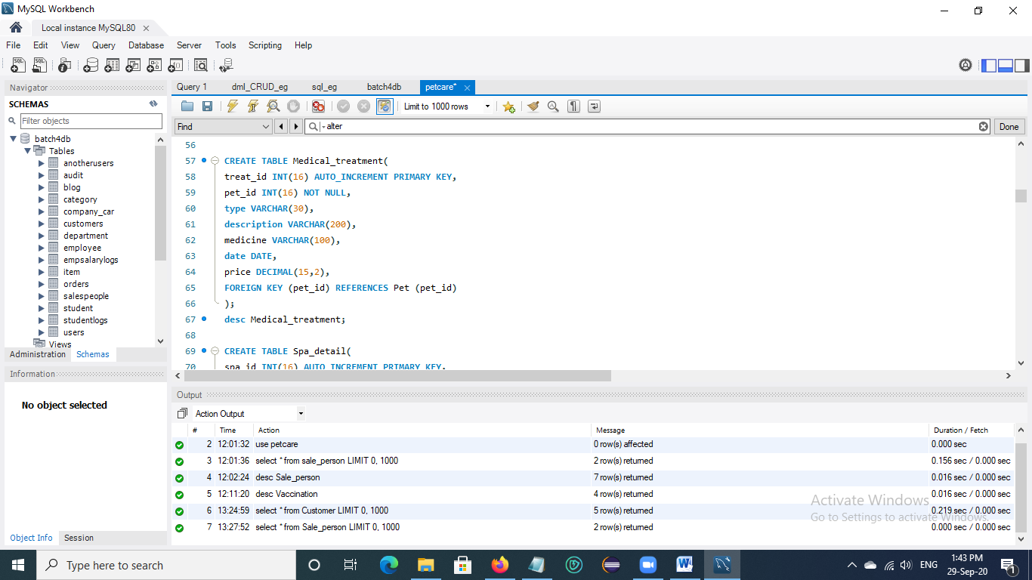

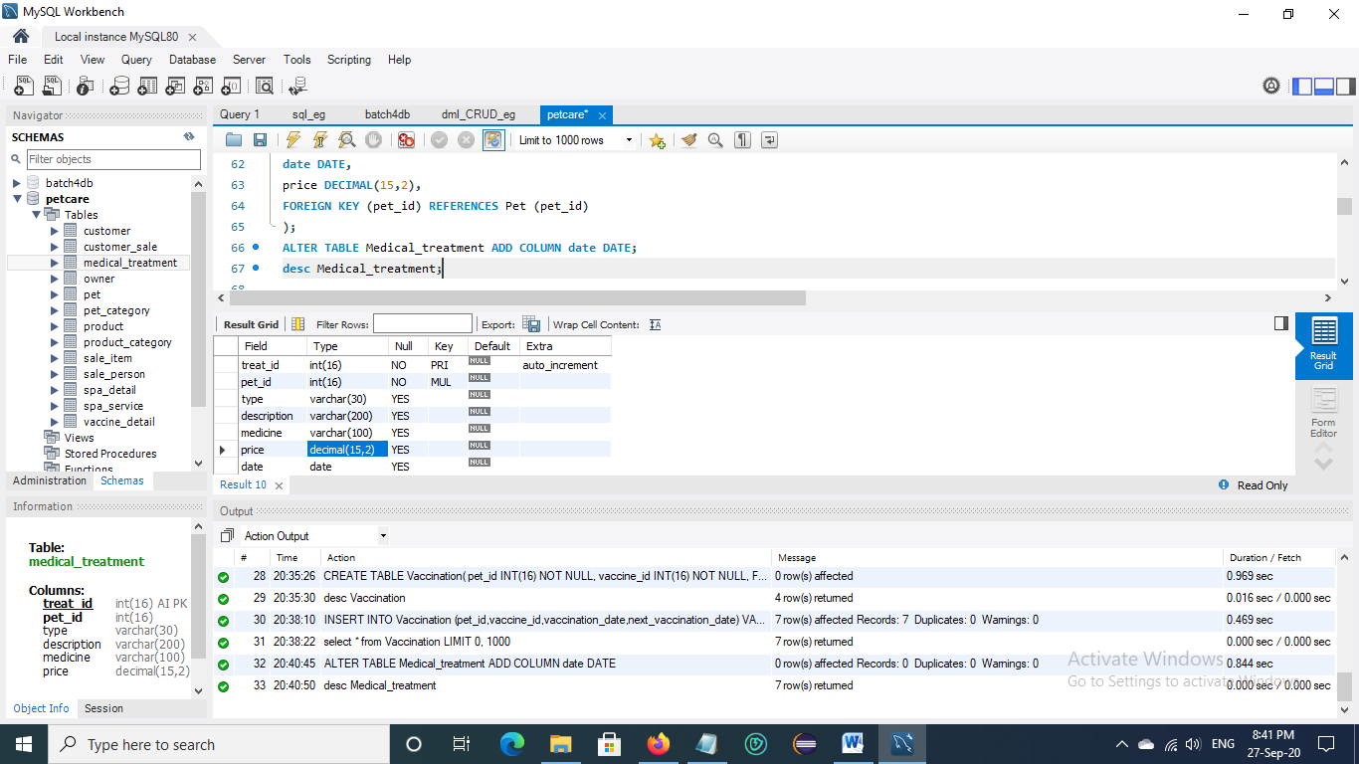

Fig. 2.7 Create Medical_treatment table

**8. Create Spa_detail table**

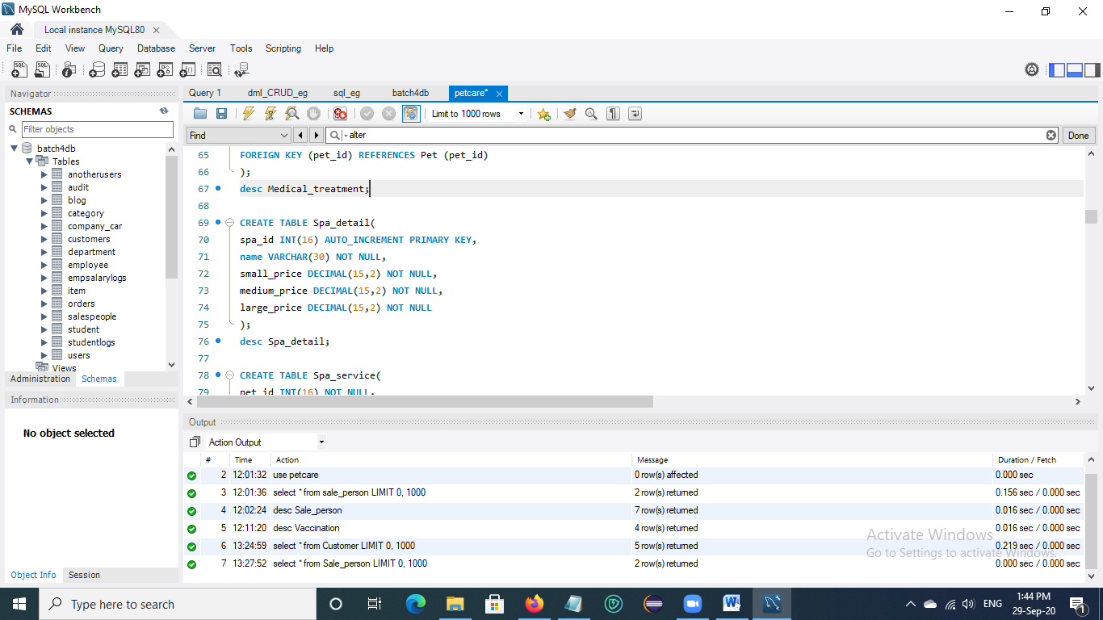

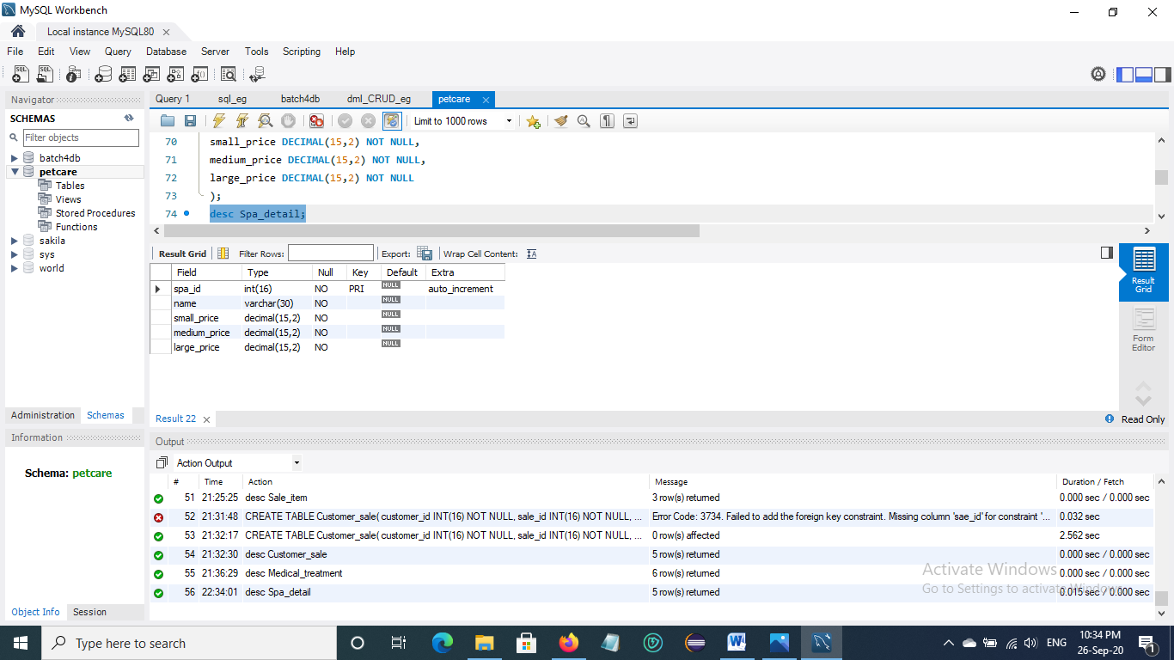

Fig. 2.8 Create Spa_detail table

**9. Create Spa_service table**

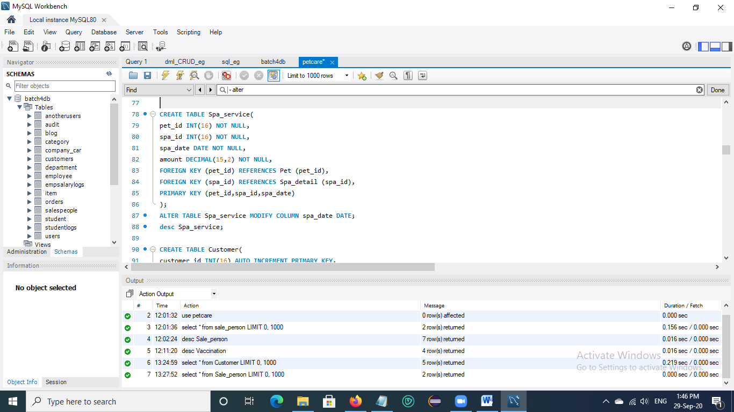

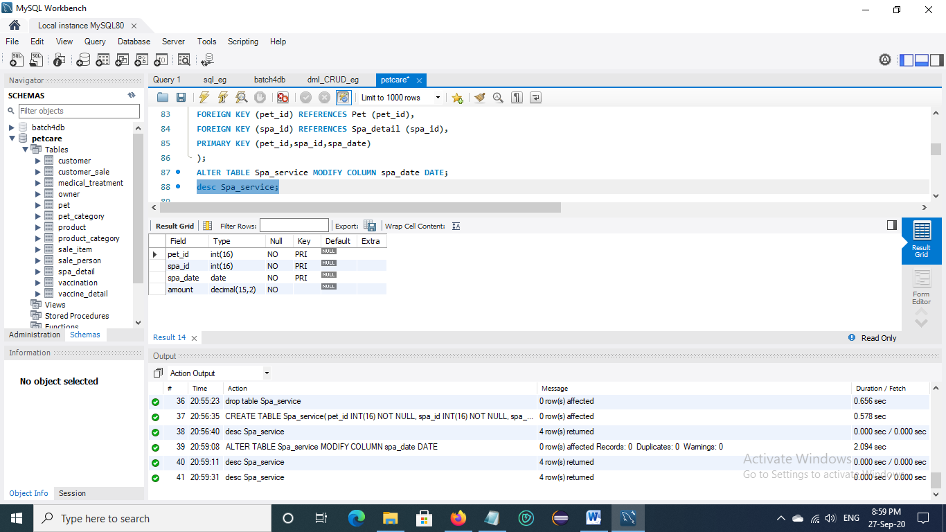

Fig. 2.9 Create Spa_service table

**10. Create Customer table**

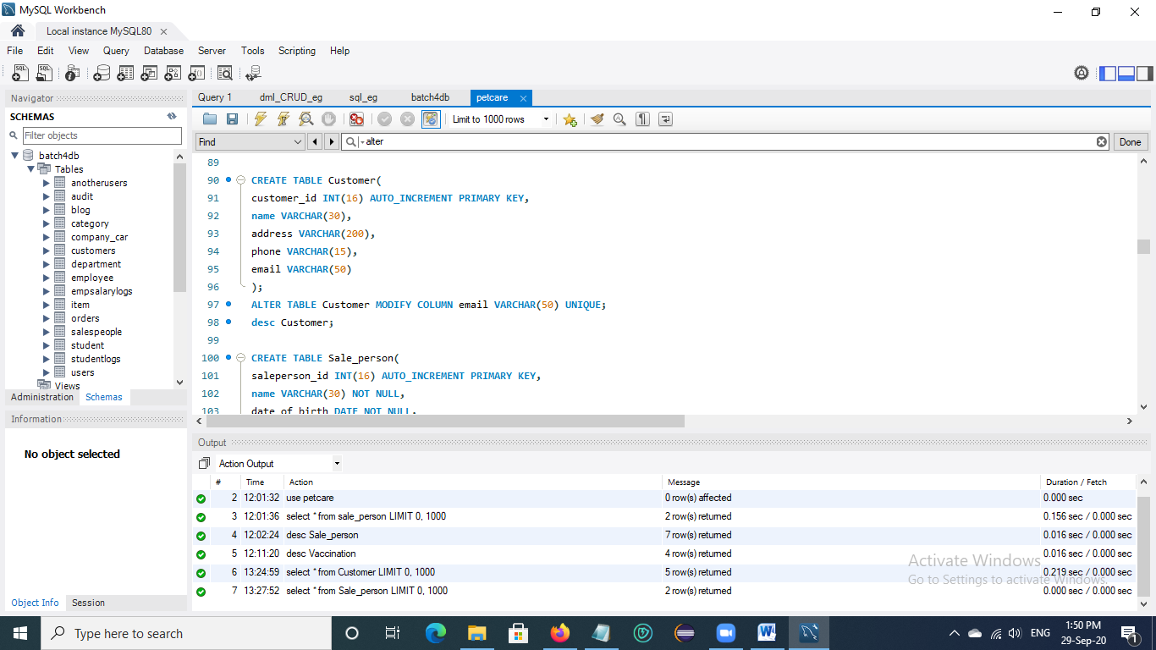

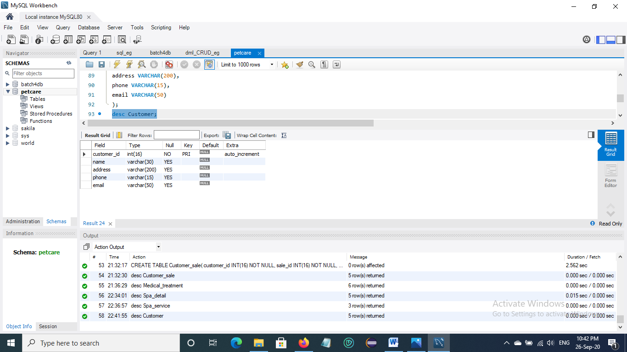

Fig. 2.10 Create Customer table

**11. Create Sale_person table**

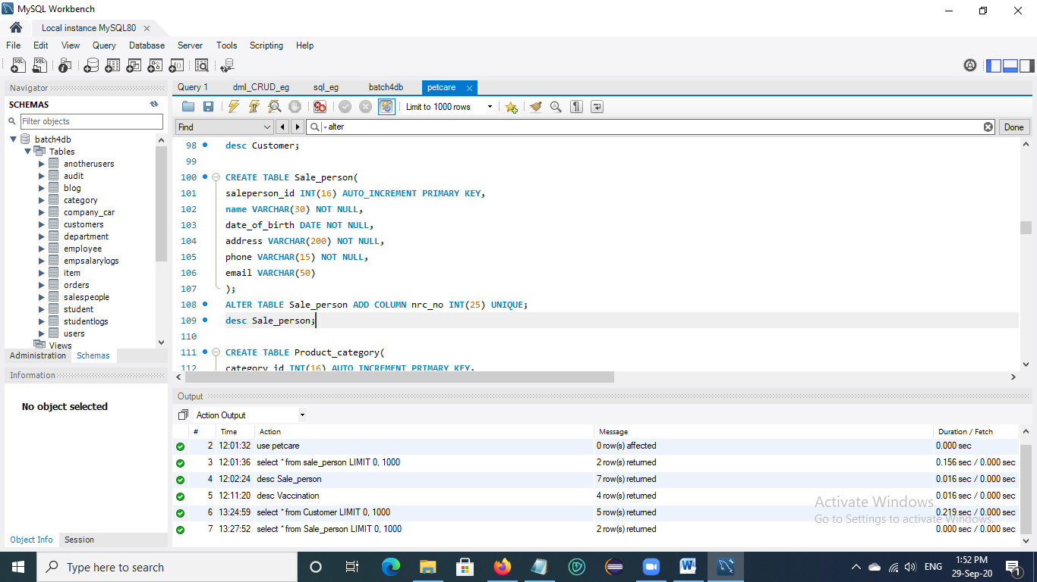

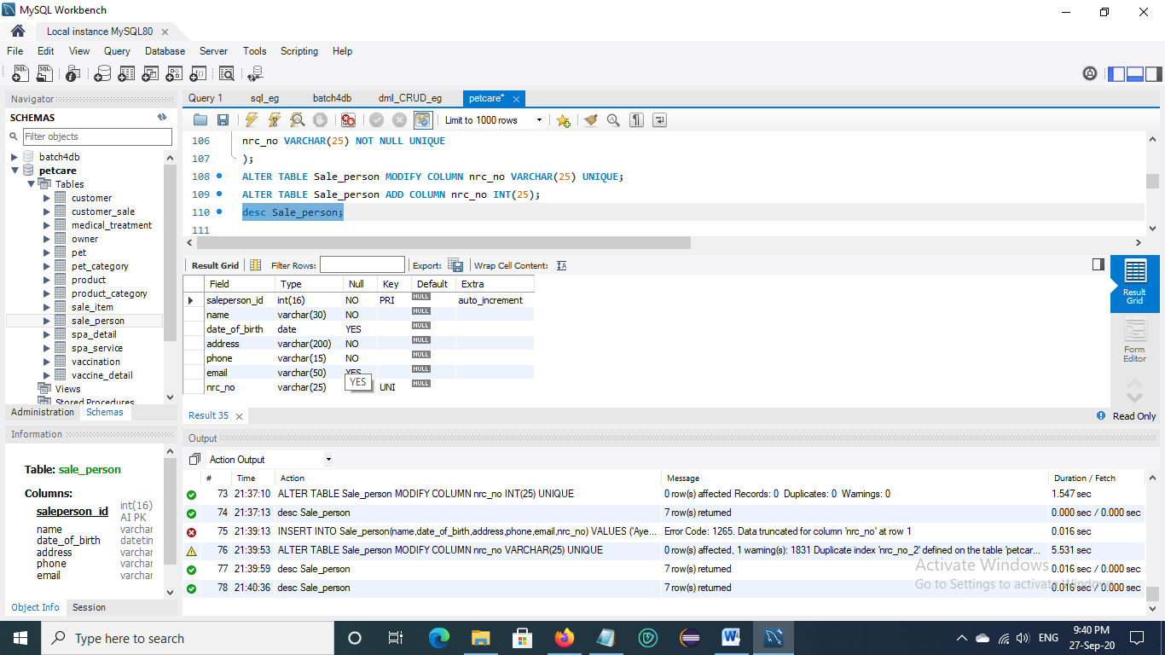

Fig. 2.11 Create Sale_person table

**12. Create Product_category table**

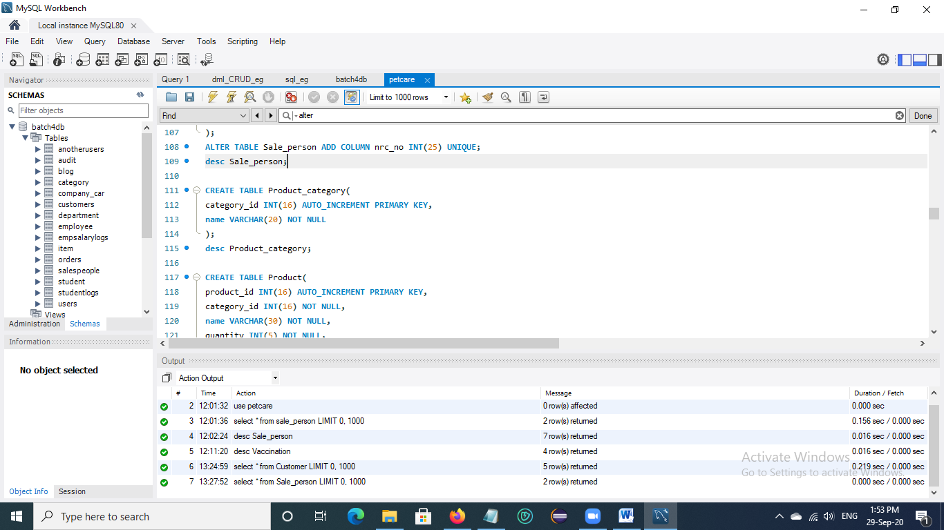

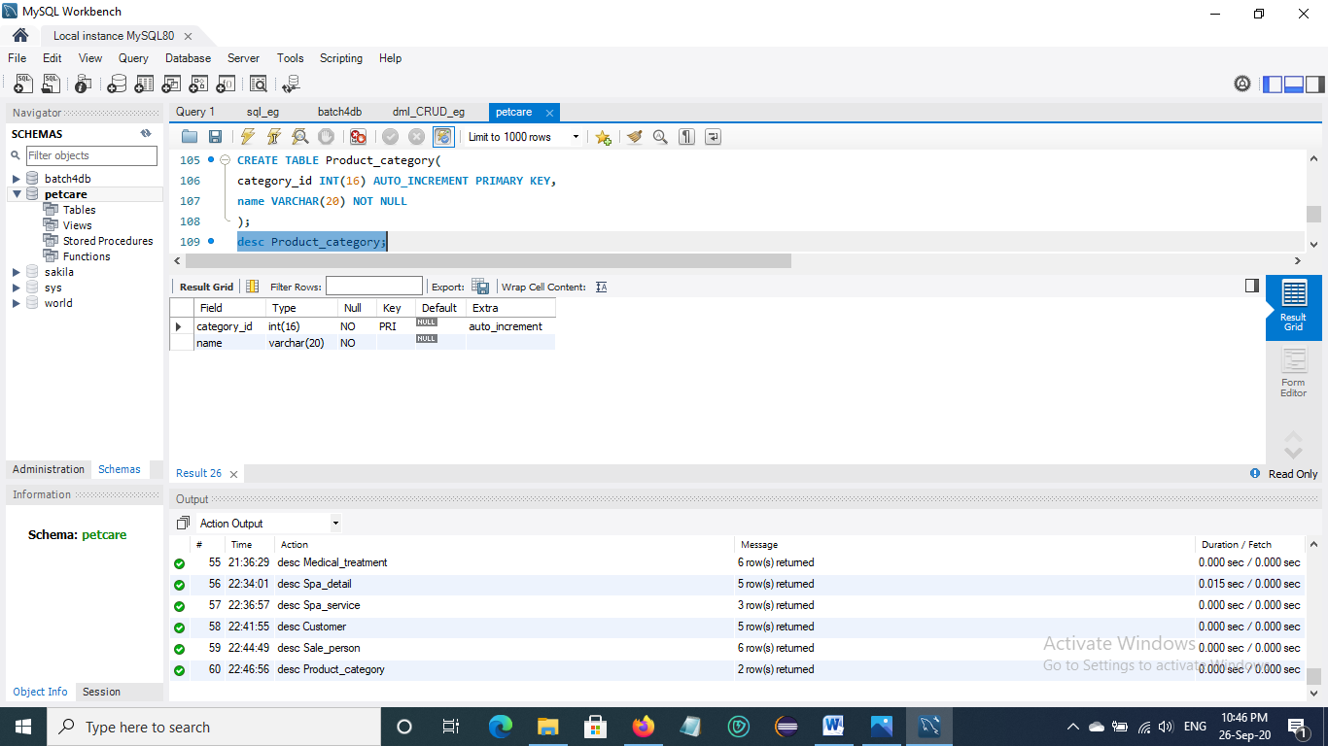

Fig. 2.12 Create Product_category table

**13. Create Product table**

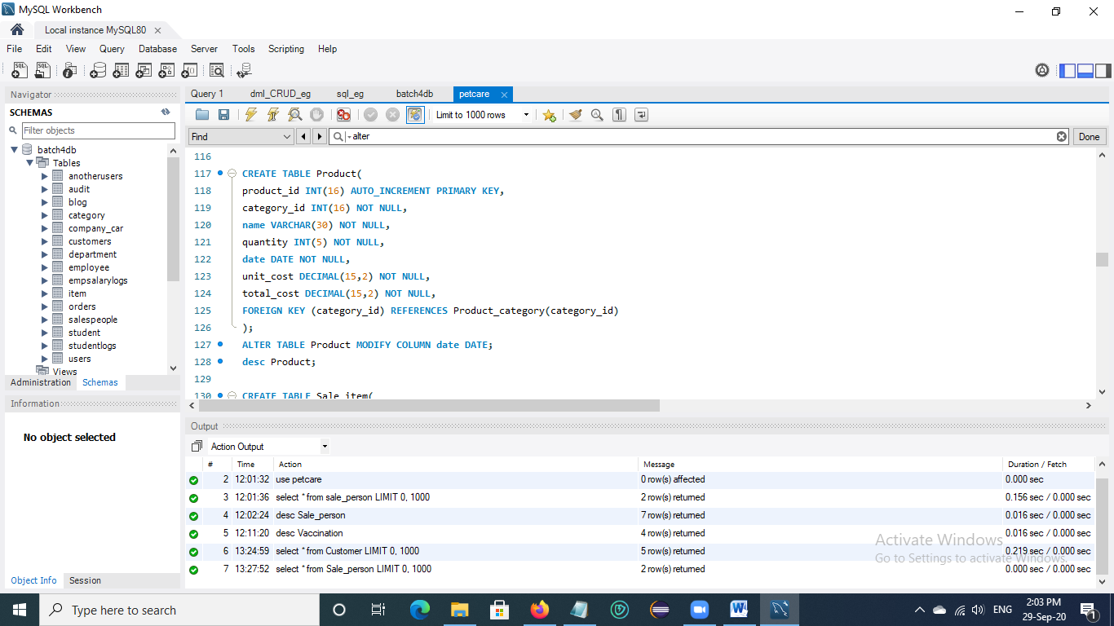

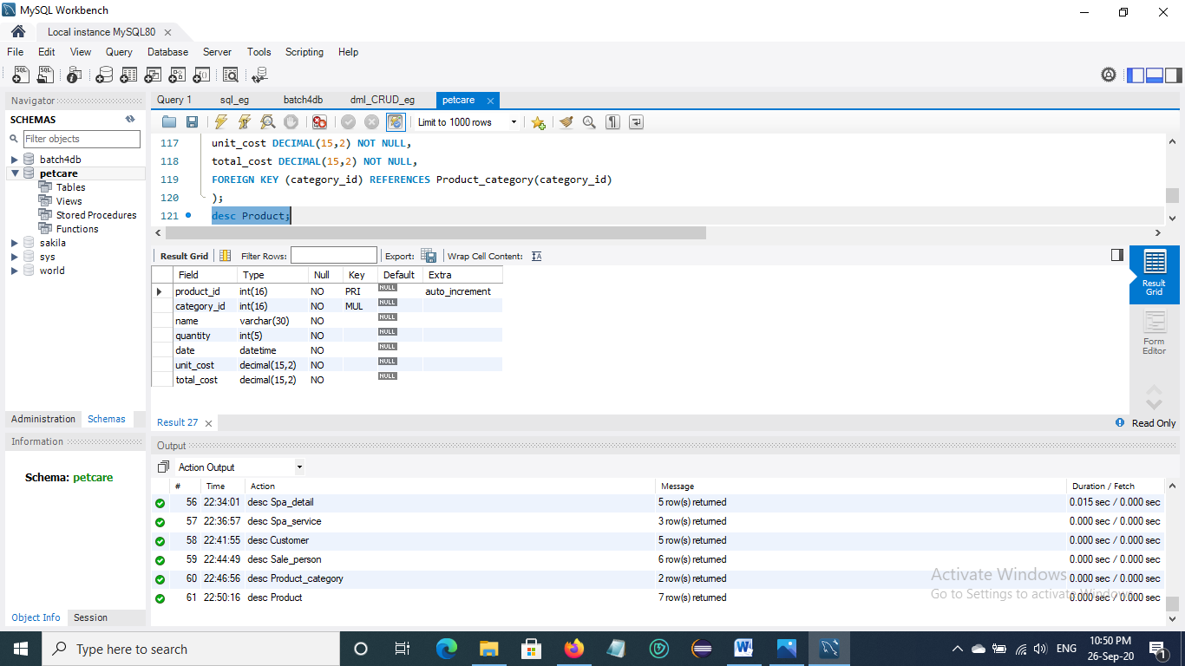

Fig. 2.13 Create Product table

**14. Create Sale_item table**

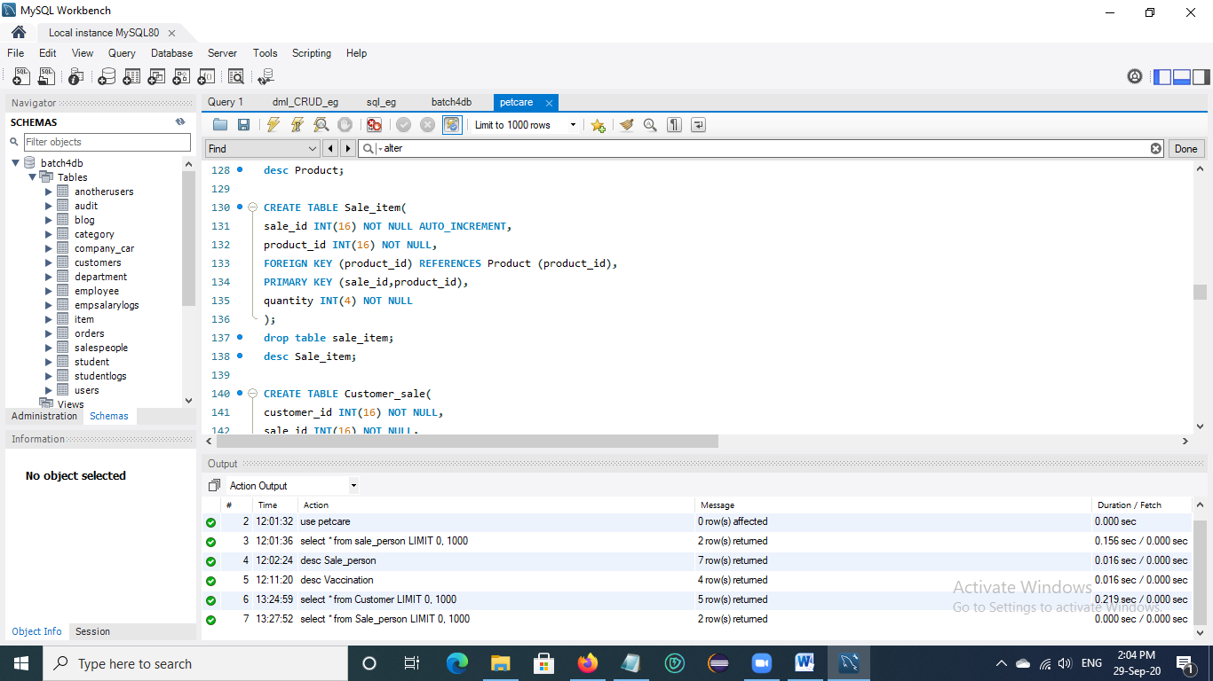

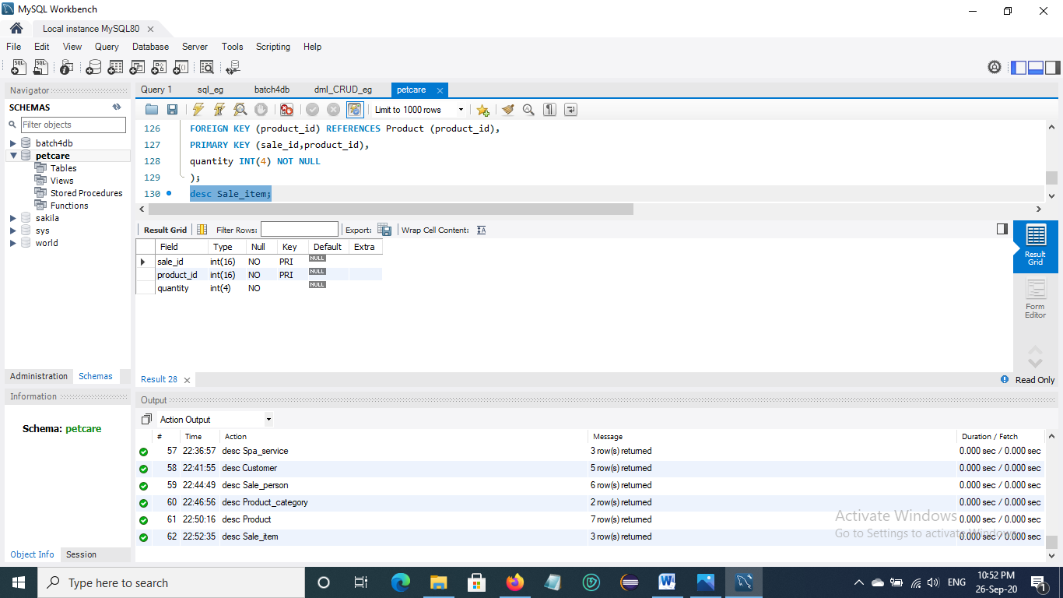

Fig. 2.14 Create Sale_item table

**15. Create Customer_sale table**

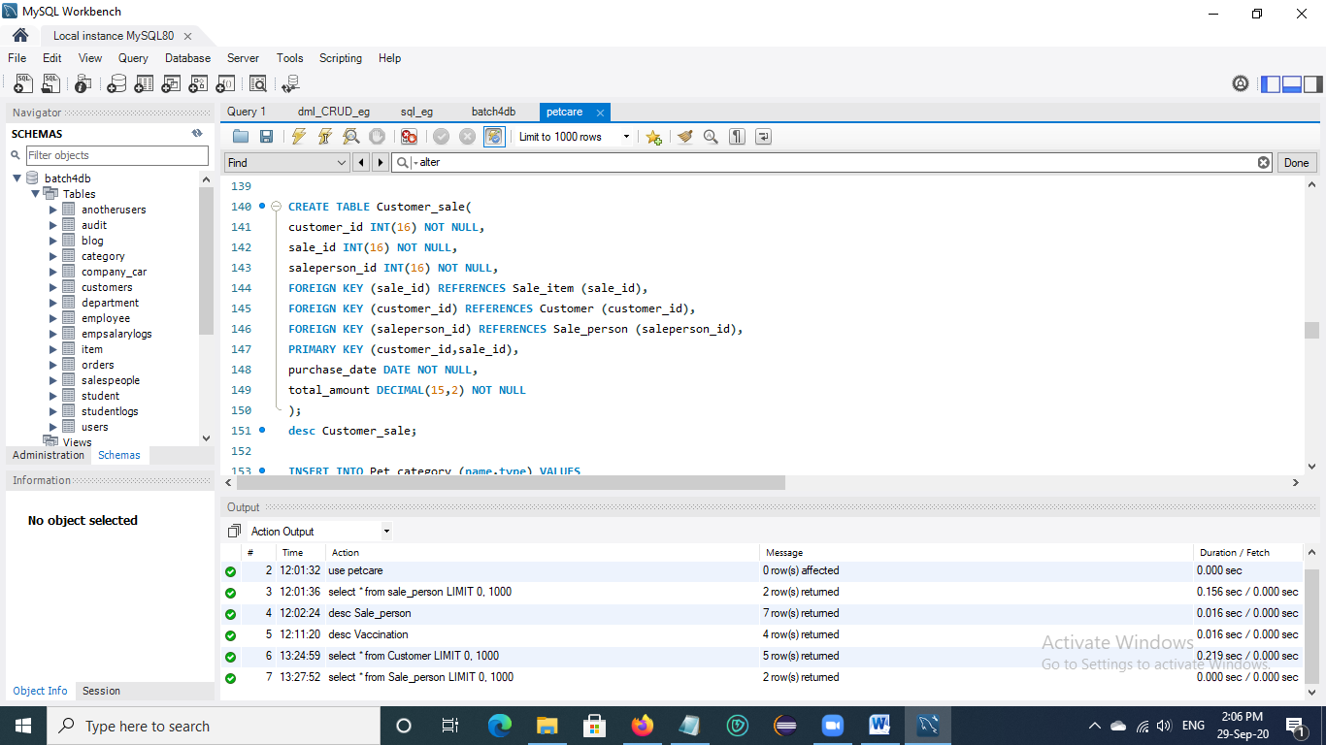

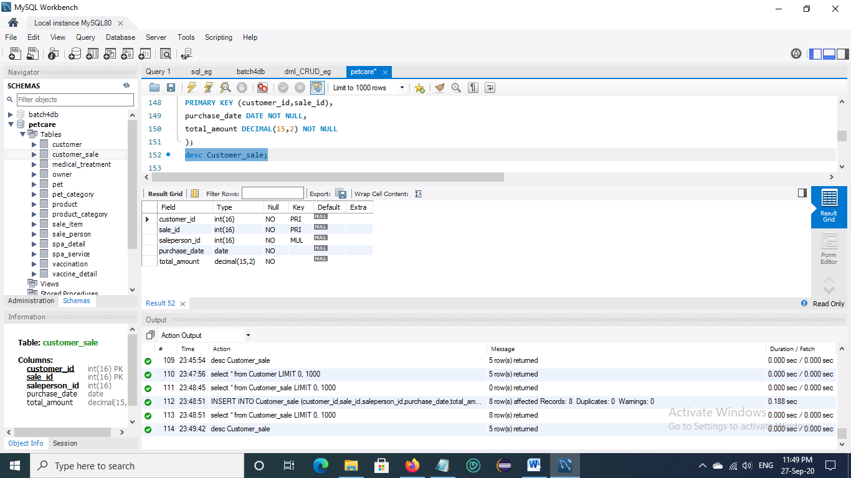

Fig. 2.15 Create Customer_sale table

## 2.2 Altering Table

**Sale_person table**

* Add new column (nrc_no) into Sale_person table

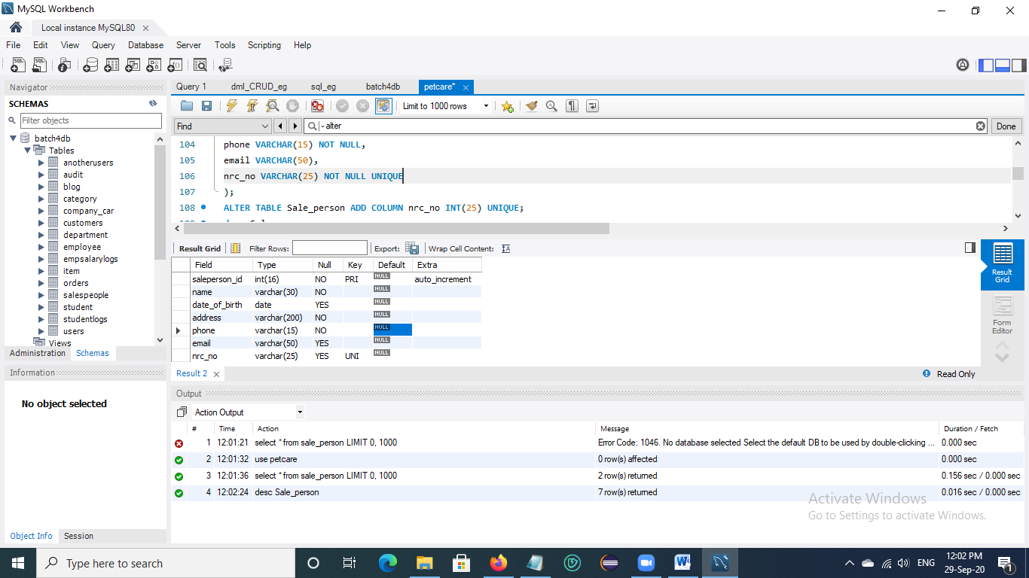

Fig. 2.16 Altering table by adding new column

**Vaccination table**

* Change data type of column in Vaccination table
* Change data type of next_vaccination_date “DATETIME” to “DATE”

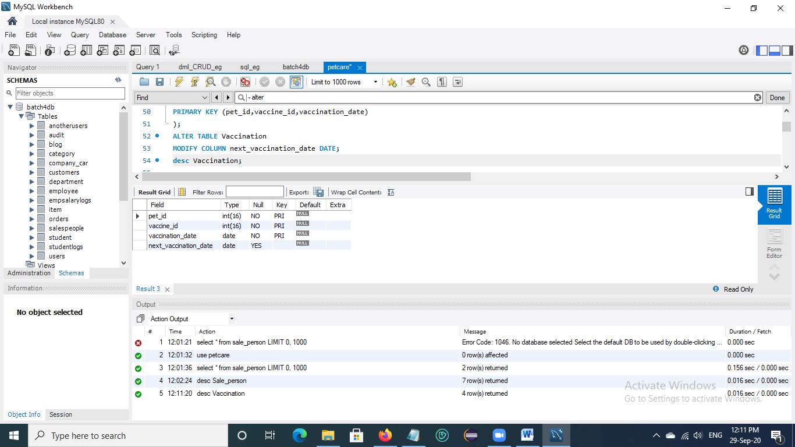

Fig. 2.17 Altering table by changing data type of existing column

## 2.3 Inserting Data to Tables

**1. Insert data into Pet_category Table**

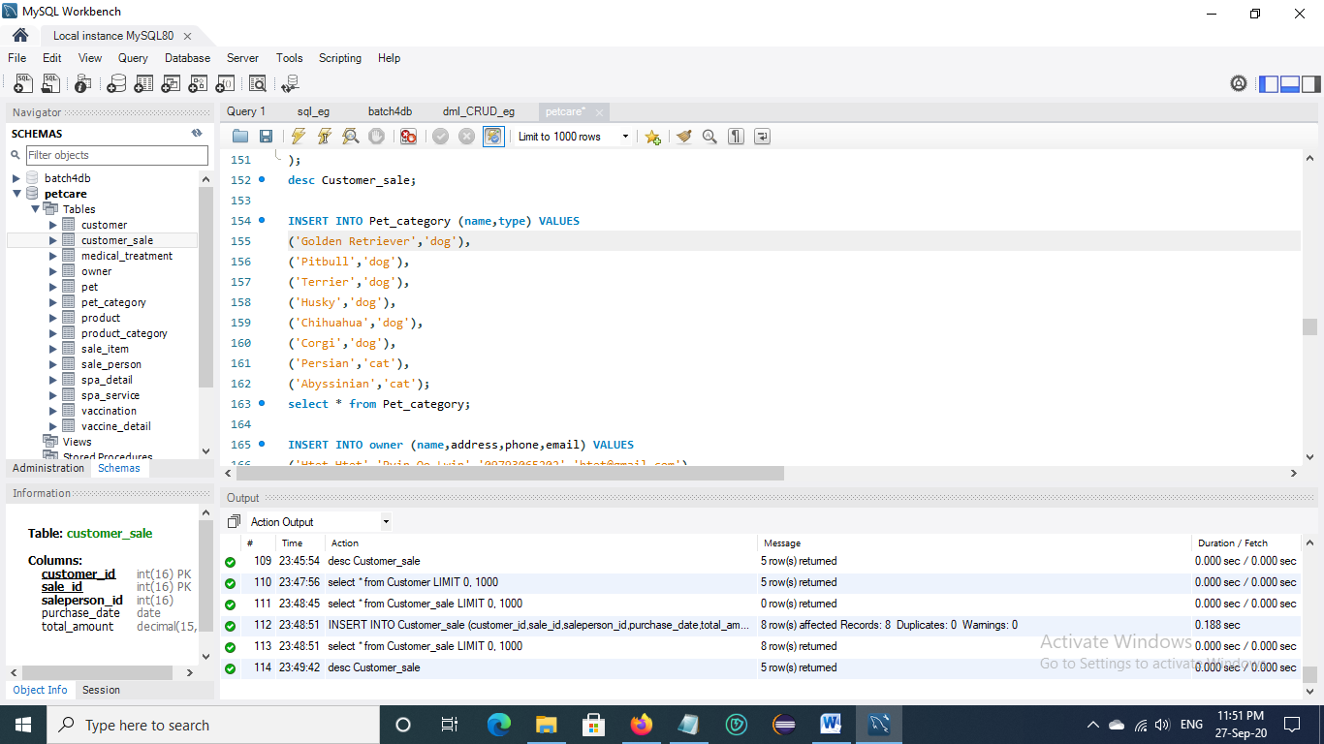

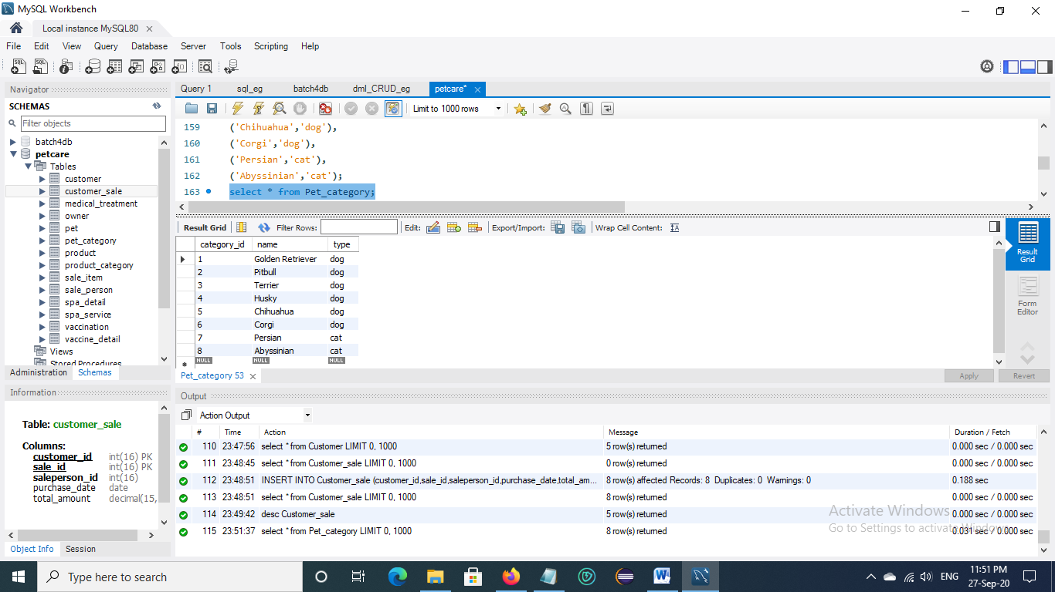

**2. Insert data into Owner Table**

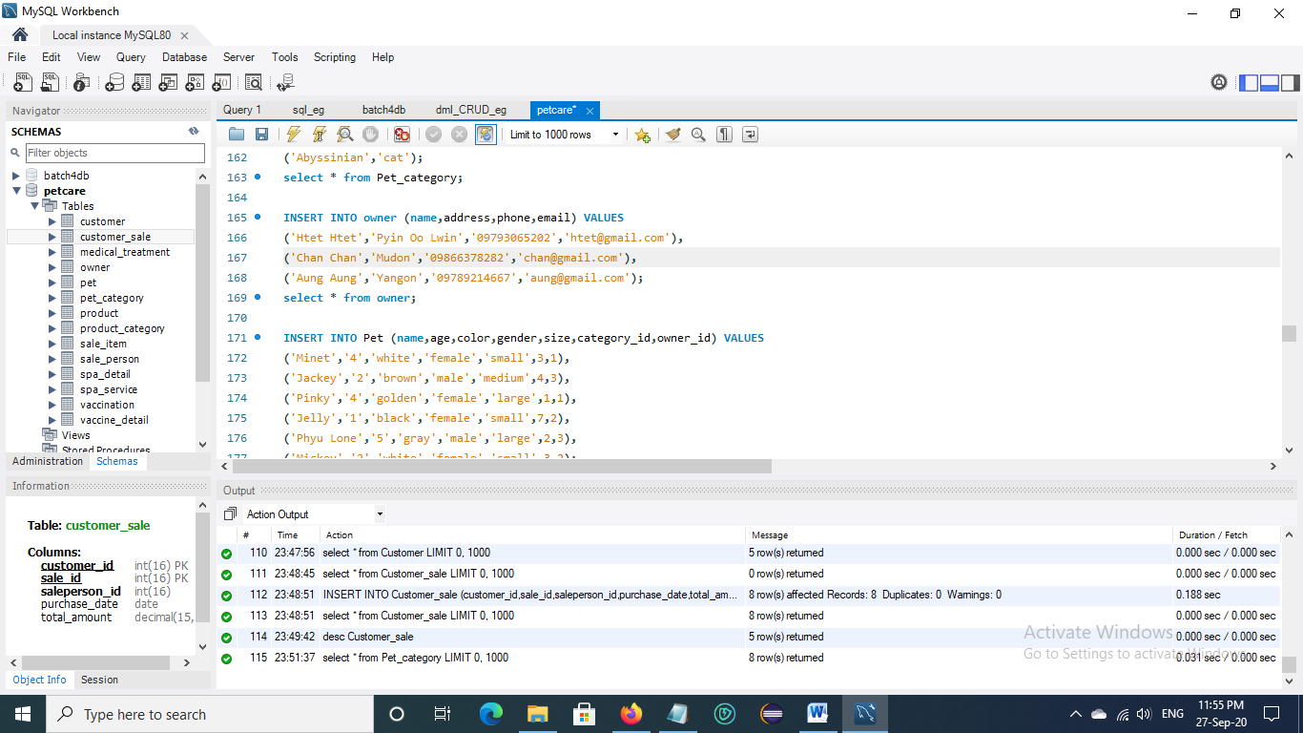

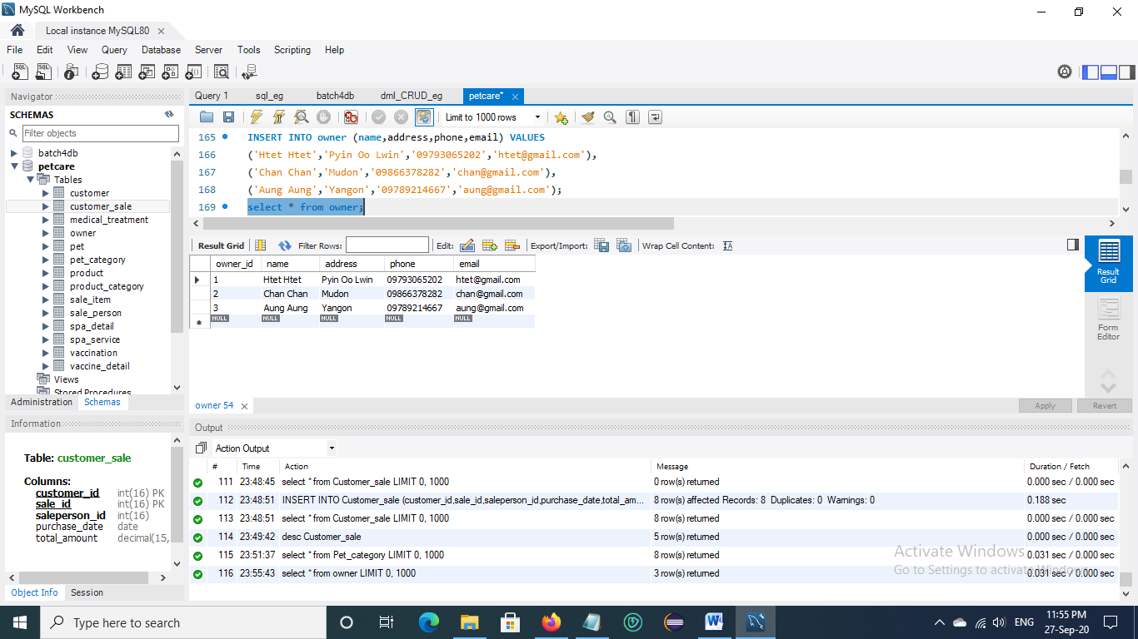

**3. Insert data into Pet Table**

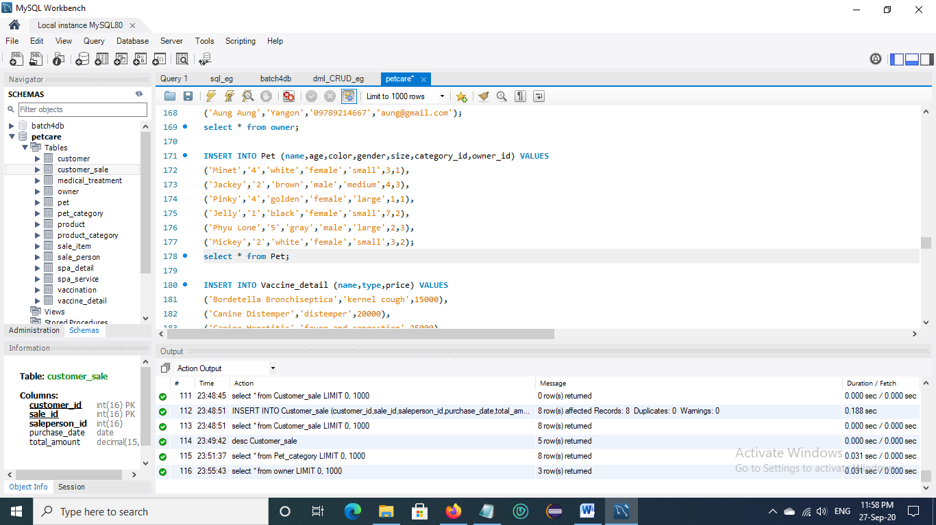

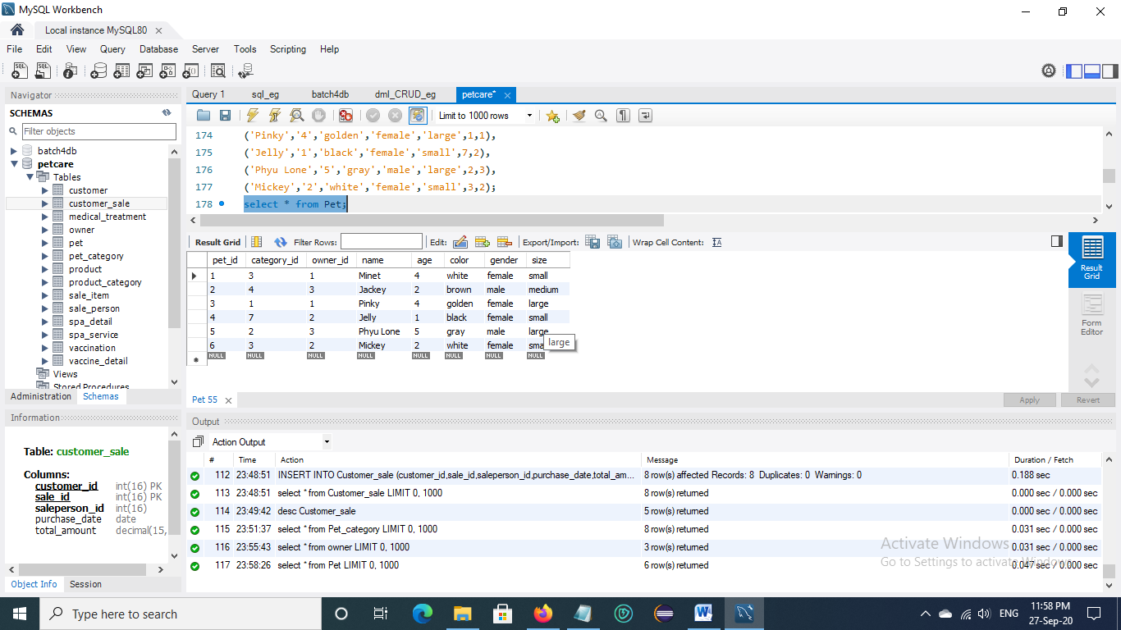

**4. Insert data into Vaccine_detail Table**

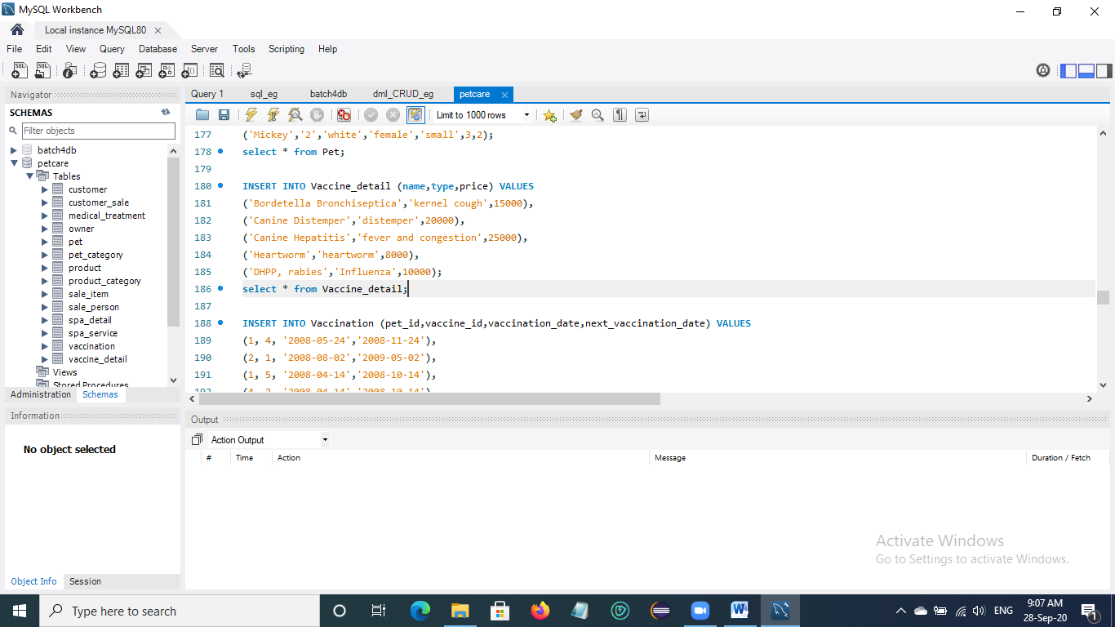

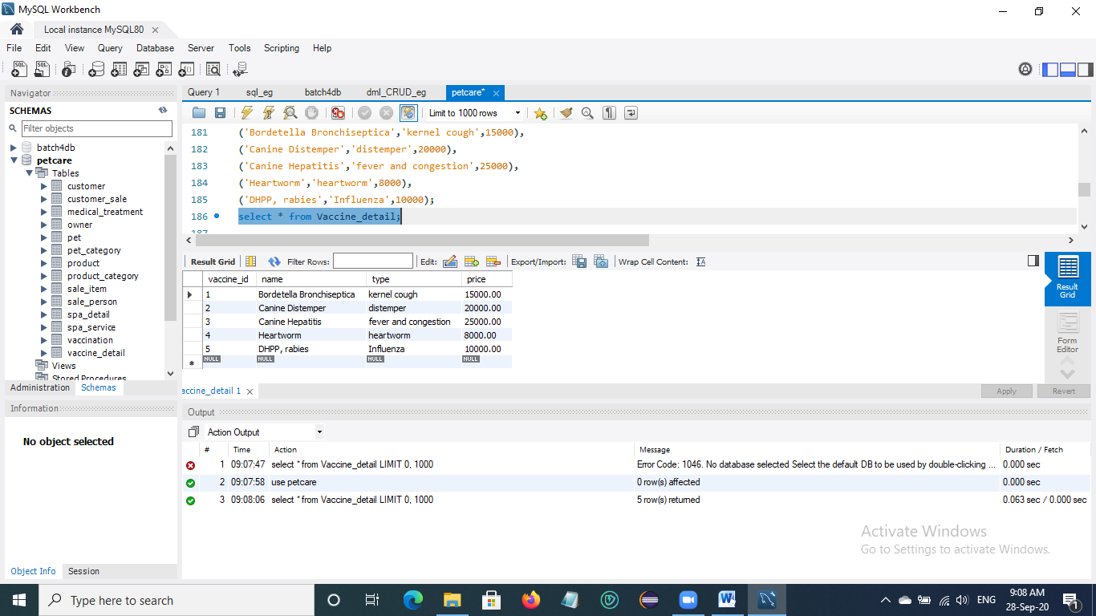

**5. Insert data into Vaccination Table**

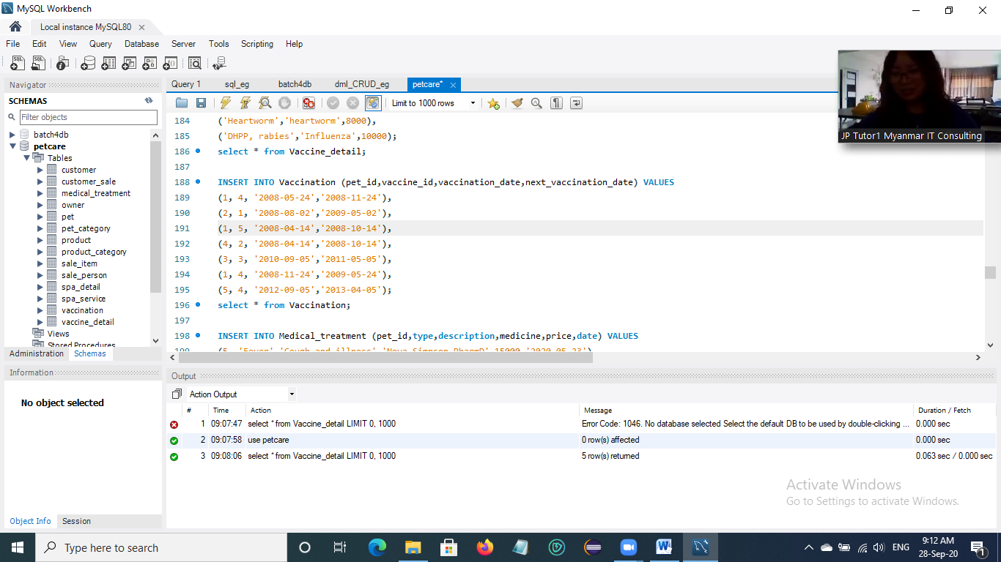

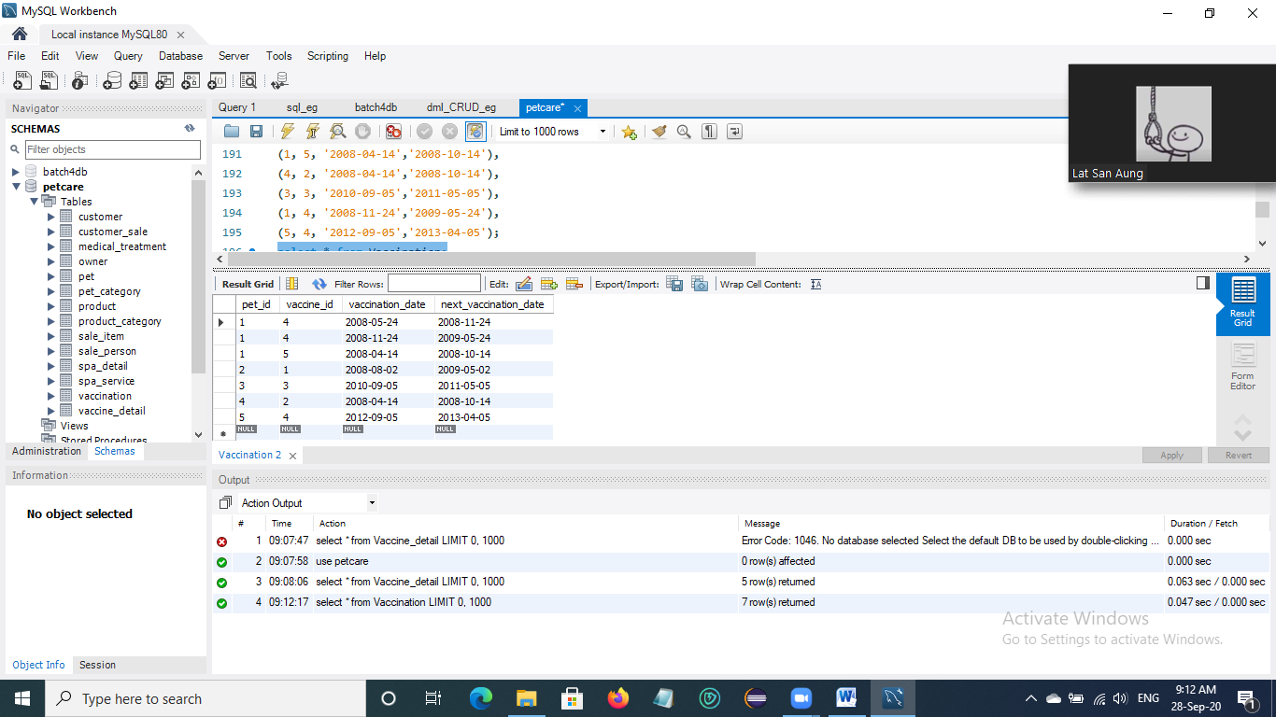

**6. Insert data into Medical_treatment Table**

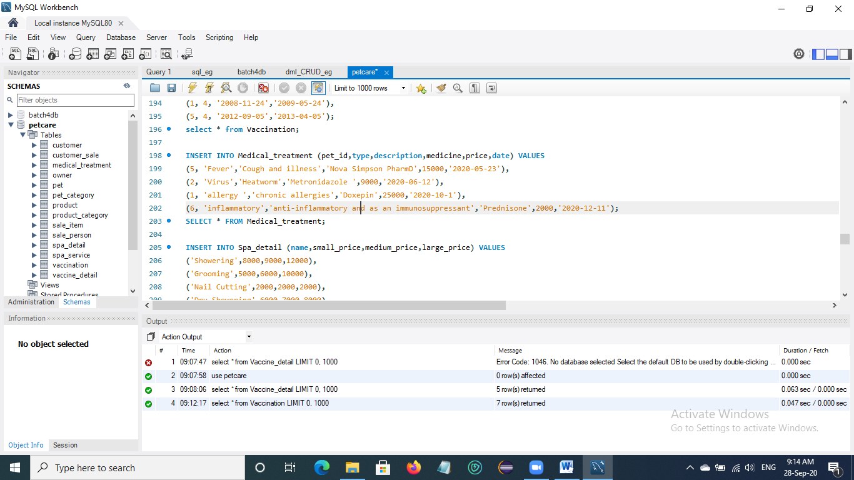

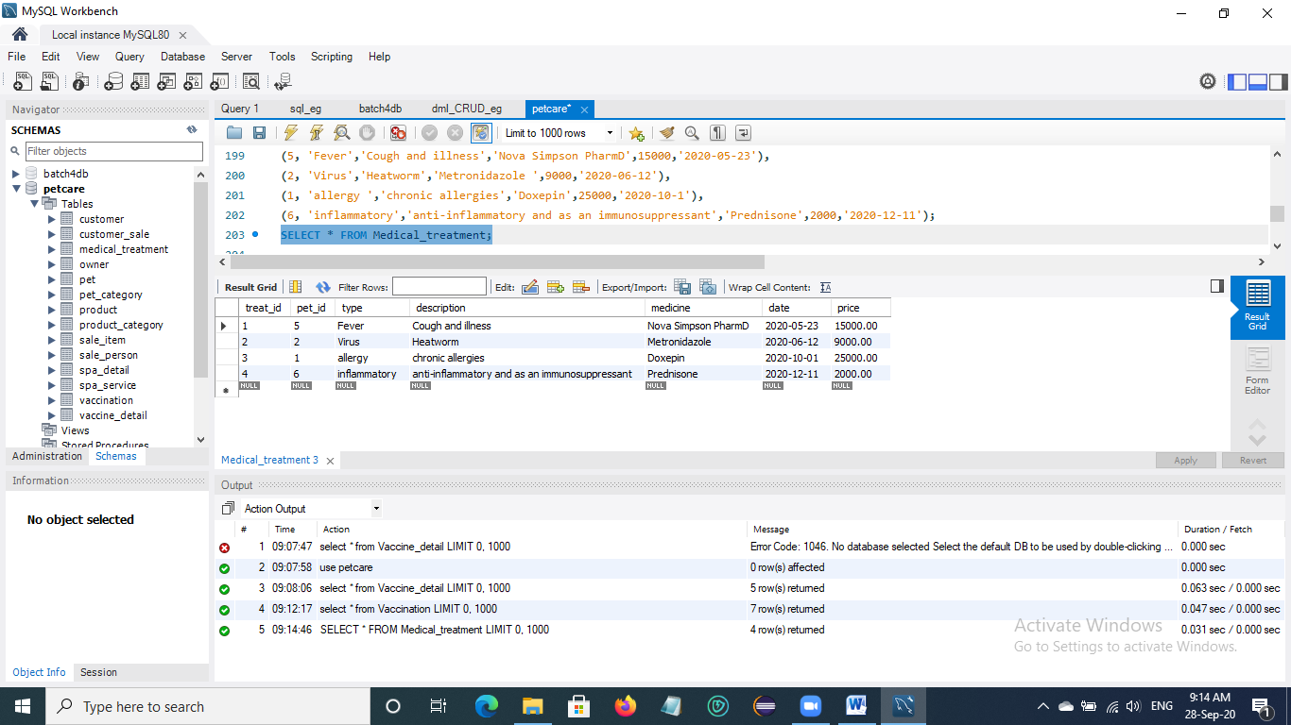

**7. Insert data into Spa_detail Table**

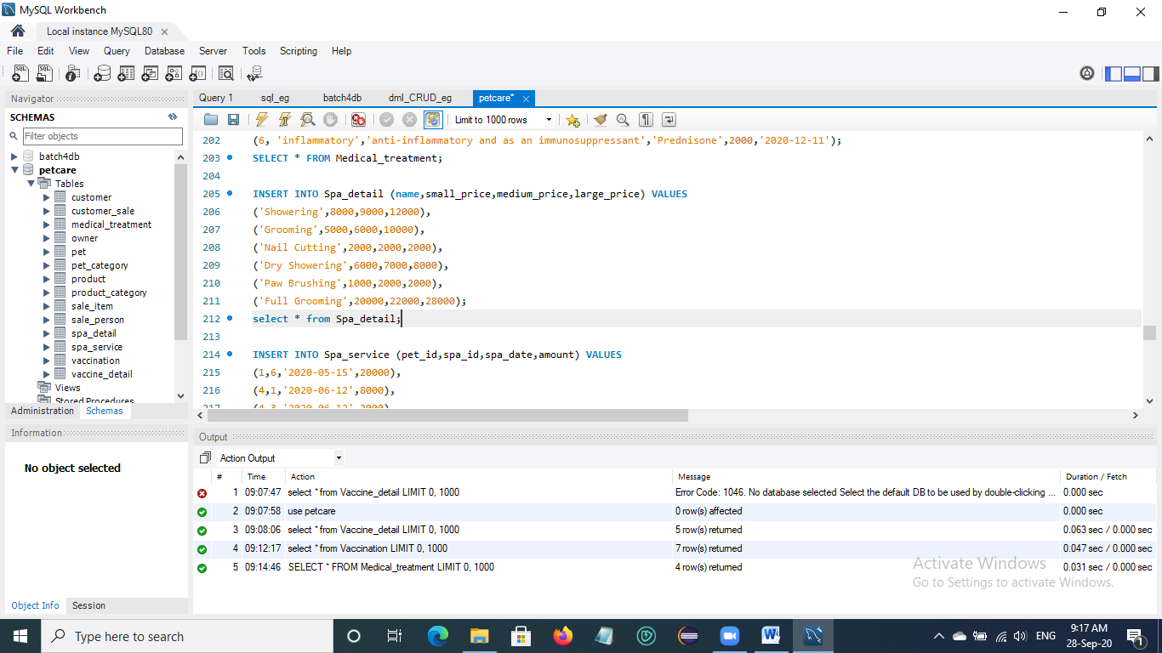

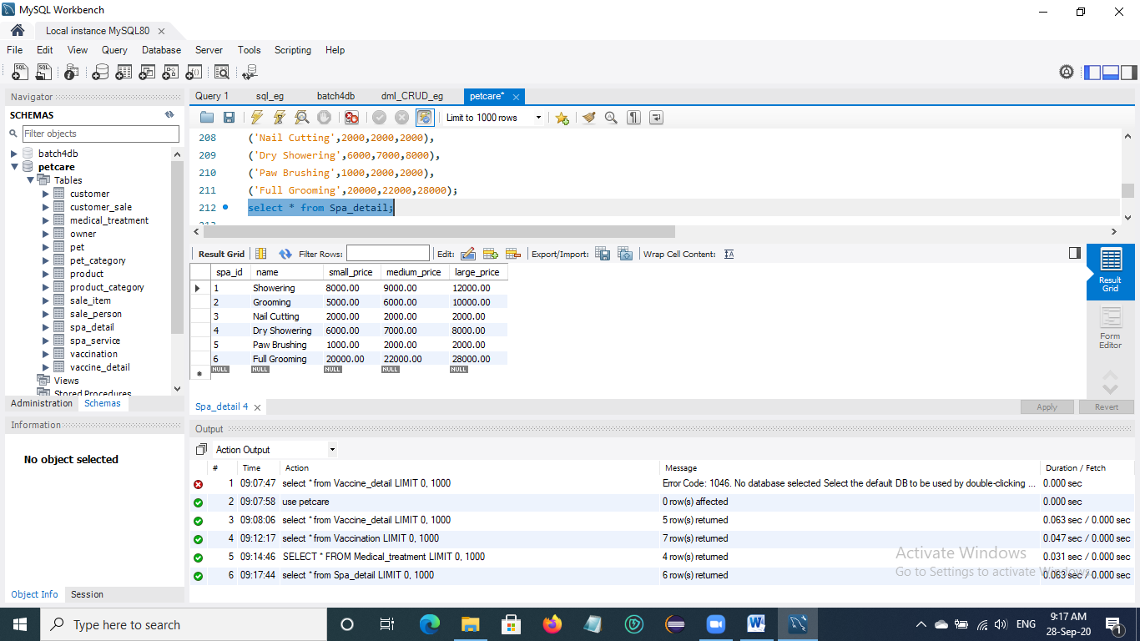

**8. Insert data into Spa_service Table**

* Create trigger ‘calculate_spa_amount’ to calculate spa service price of each pet by its size ‘small’ or ‘medium’ or ‘large’.

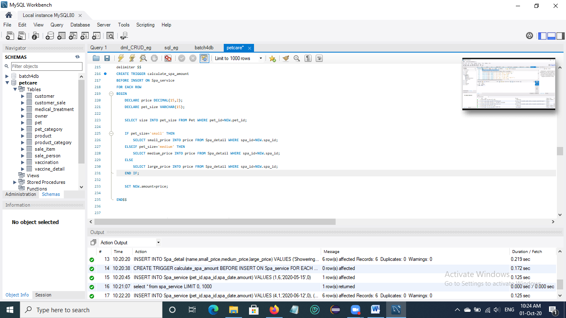

* Insert data into Spa_service table.

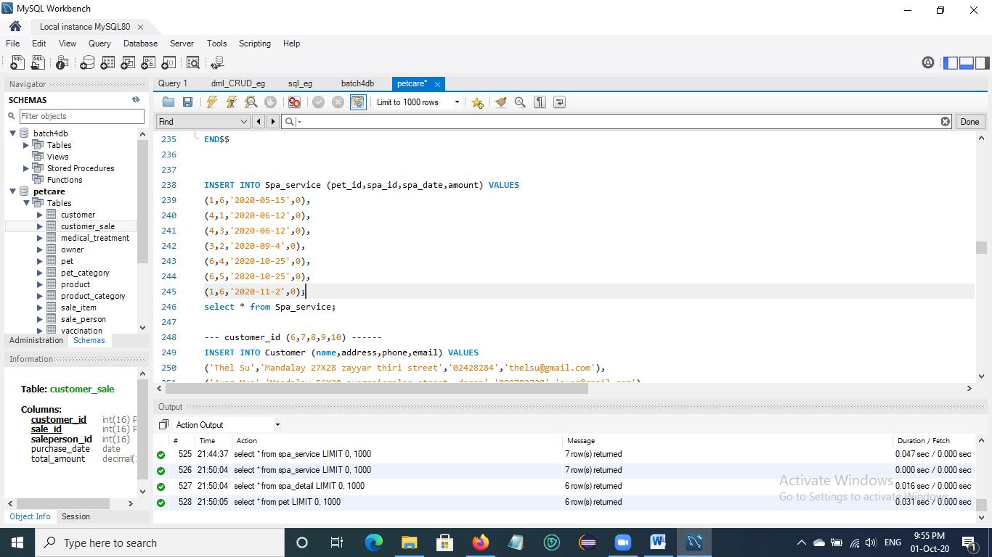

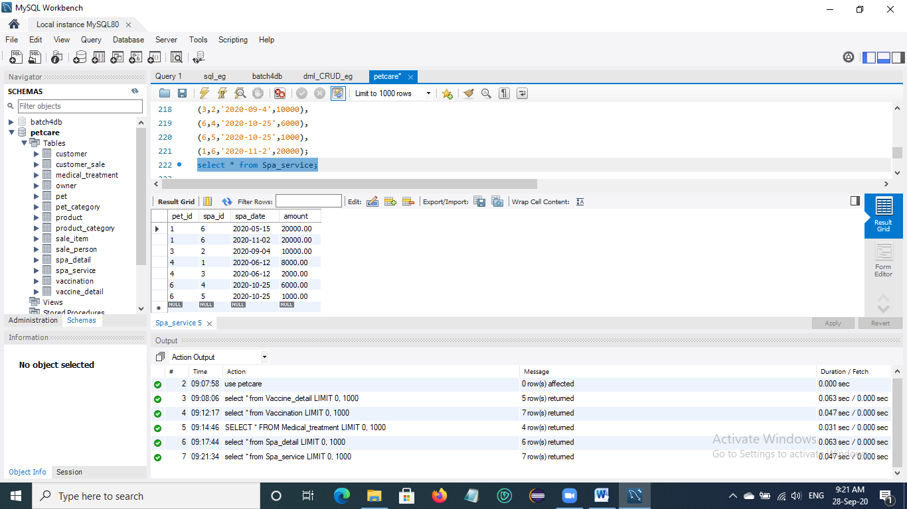

**9. Insert data into Customer Table**

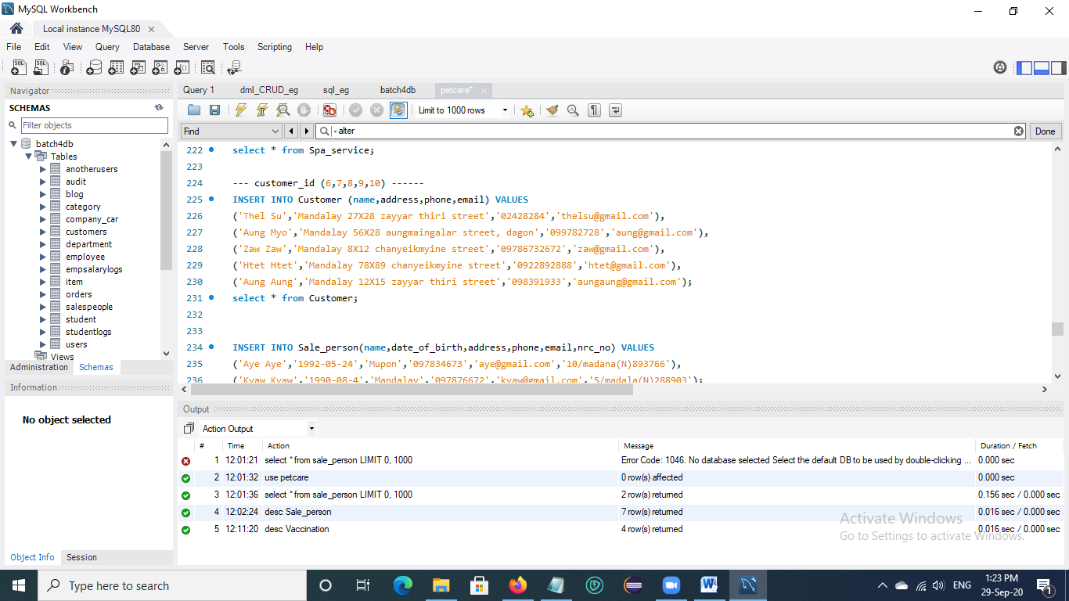

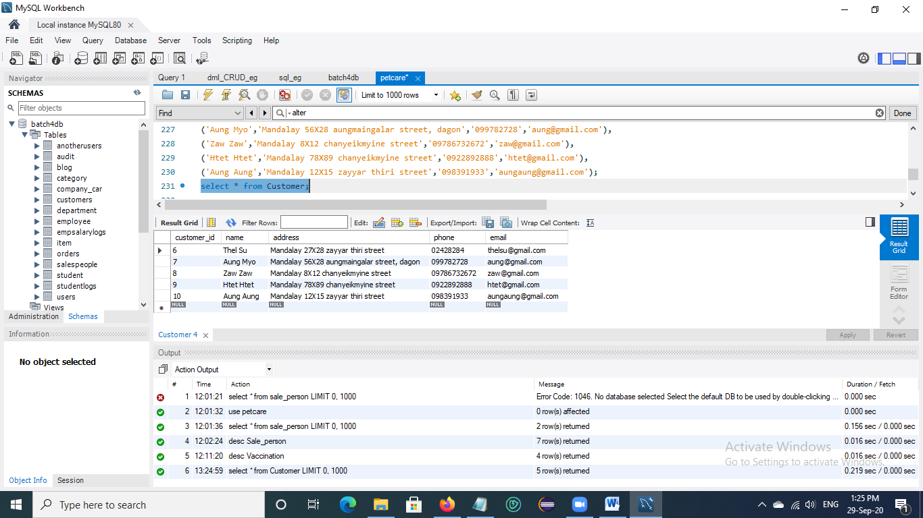

**10. Insert data into Sale_person Table**

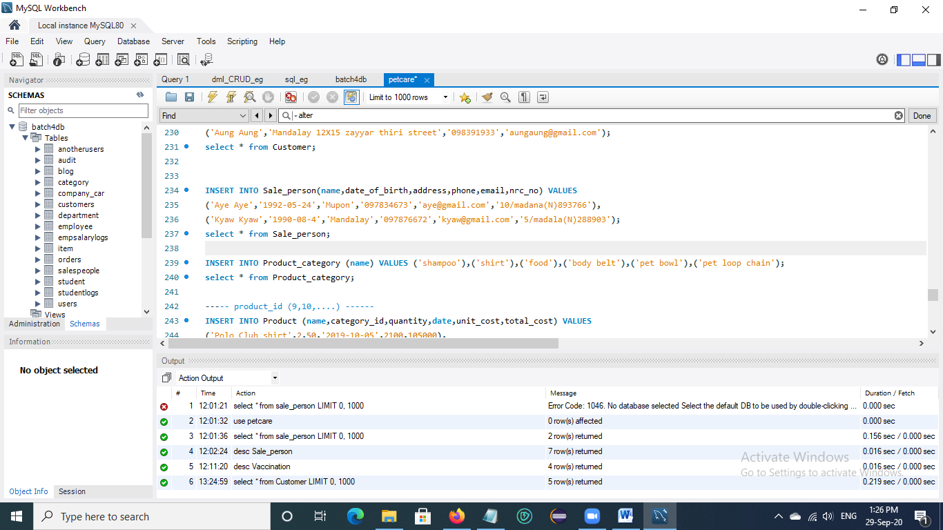

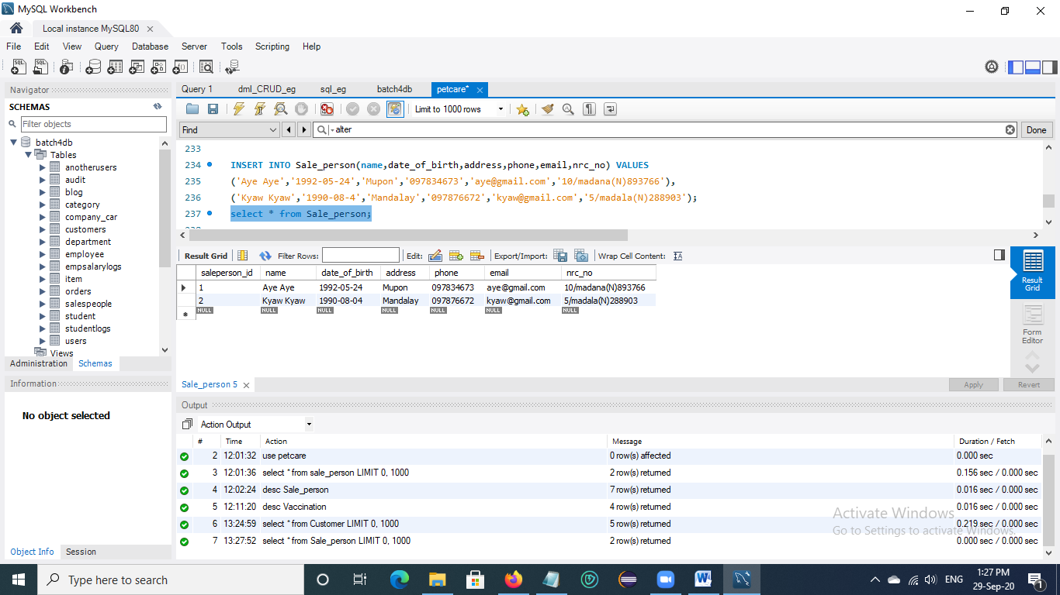

**11. Insert data into Product_category Table**

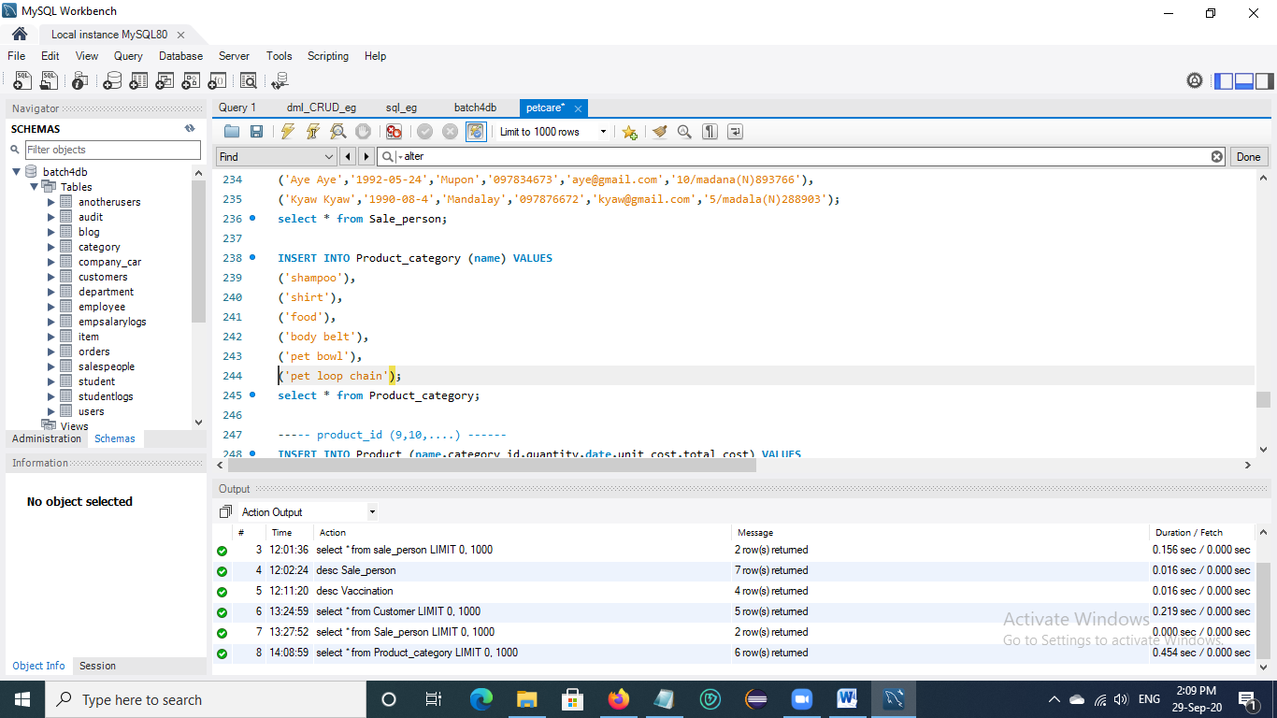

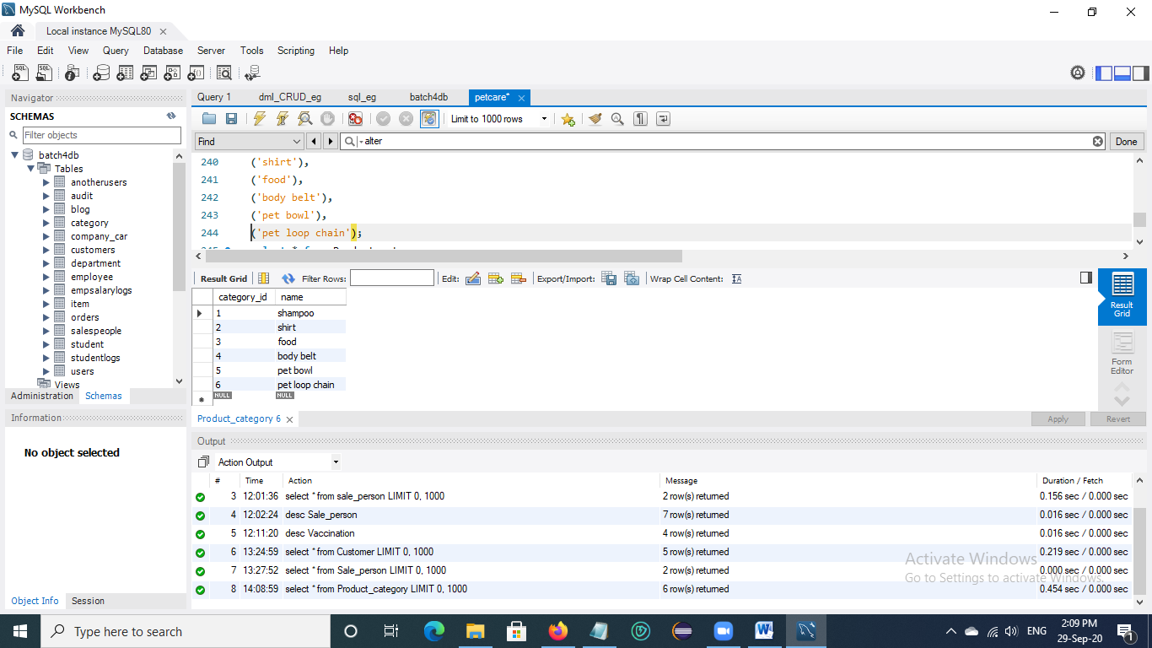

**12. Insert data into Product Table**

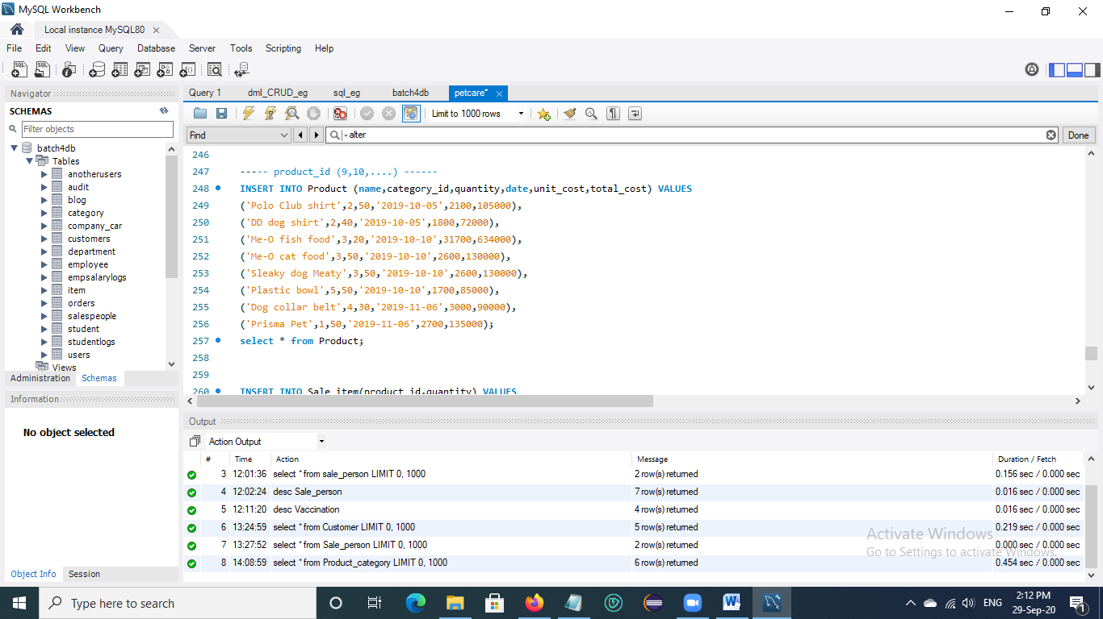

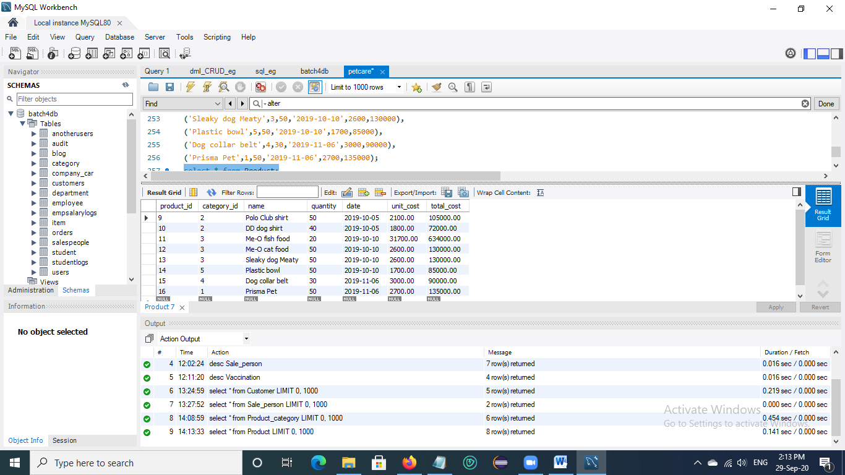

**13. Insert data into Sale_item Table**

* Create trigger ‘update_product_qty’ to reduce and update total quantity of product in Product table after inserting data into Sale_item table.

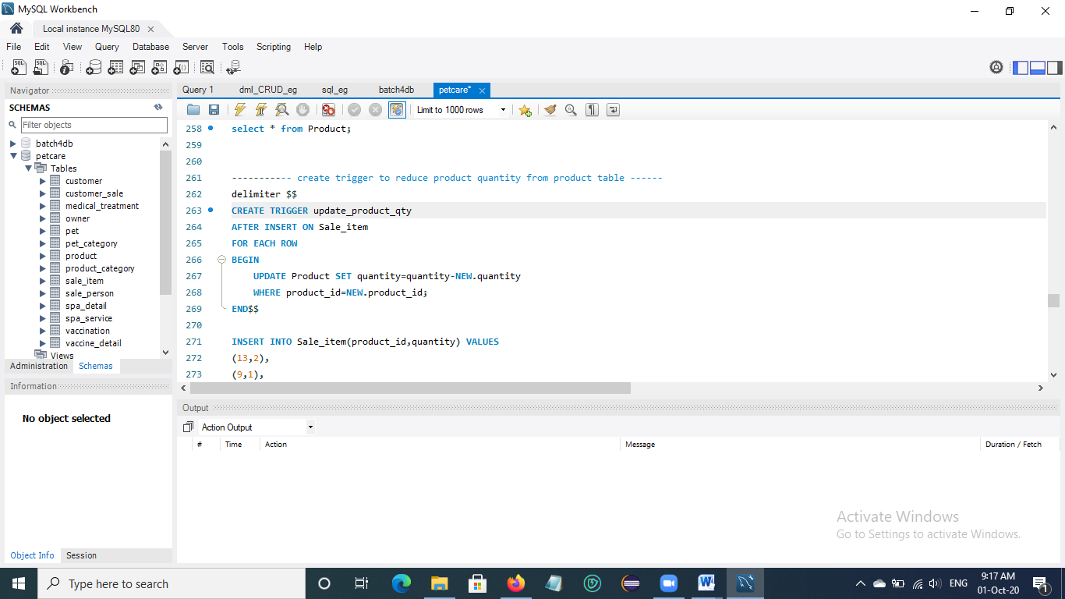

* Insert data into Sale_item table.

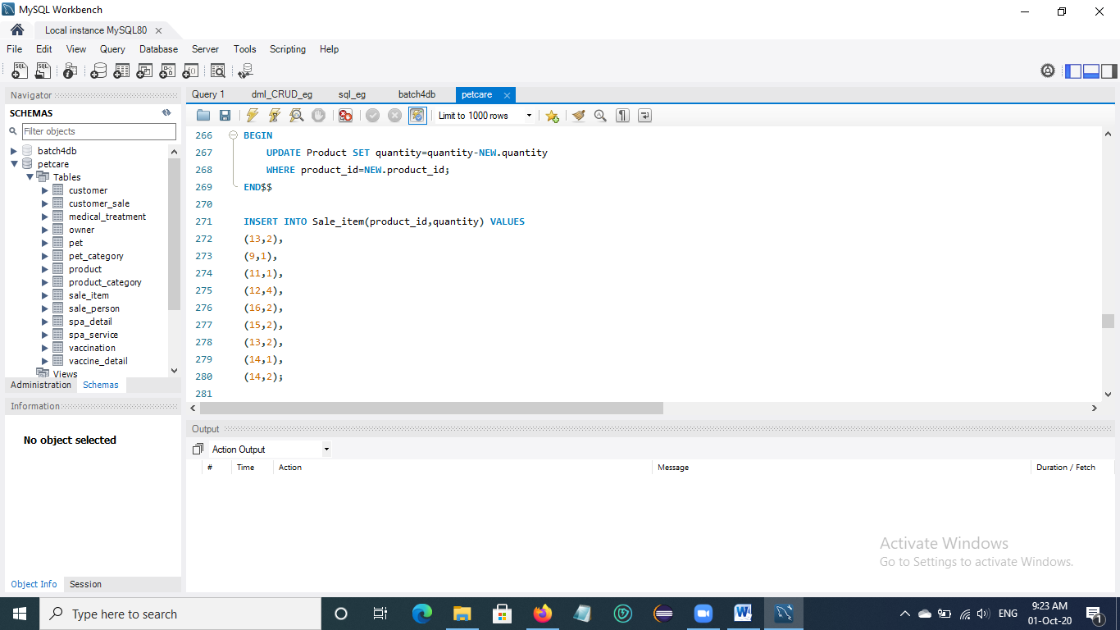

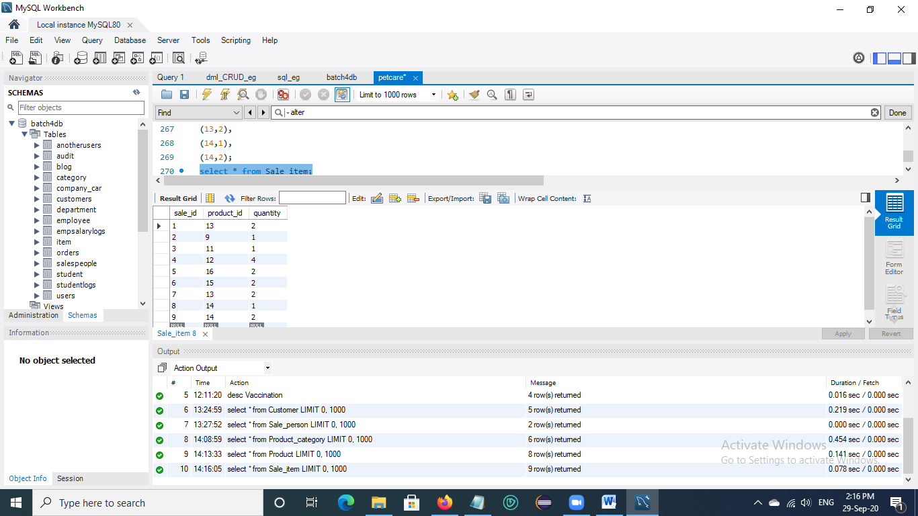

**14. Insert data into Customer_sale Table**

* Create trigger ‘total_amount’ to calculate the total amount of customer sale by multiplying unit cost and quantity of Product.

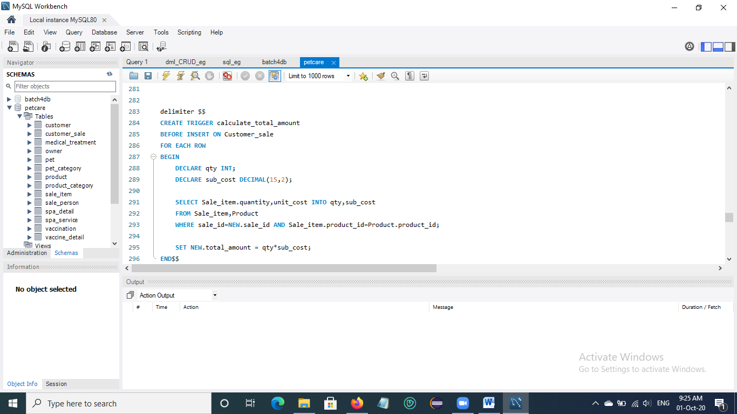

* Insert data into Customer_sale table.

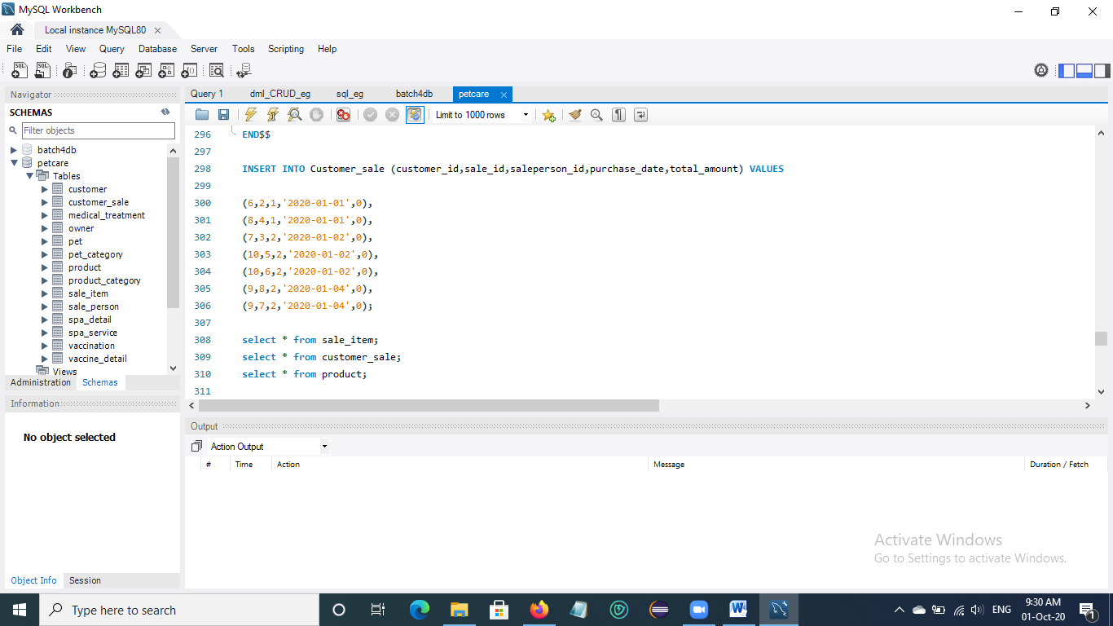

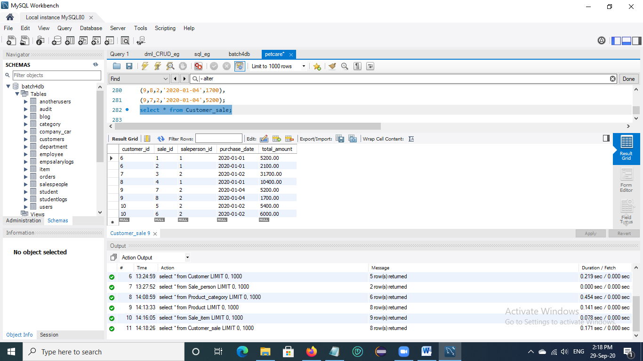

# Chapter 3

# Data Retrieval

## 3.1 Display vaccine name, type and price that is the most service in this pet care clinic

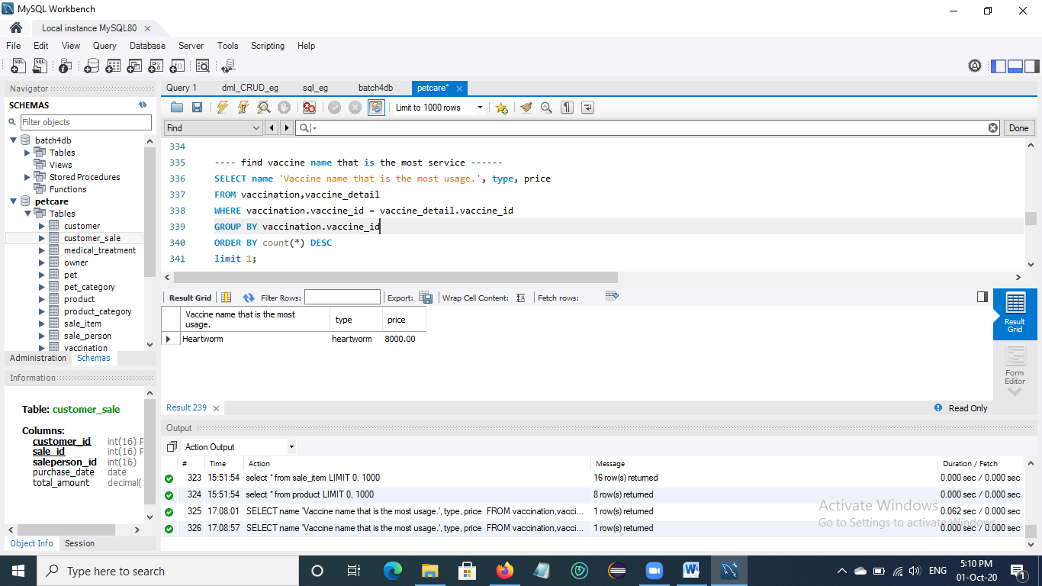

## 3.2 Display Spa Services detail that are served by pet name 'Minet' and 'Mickey'

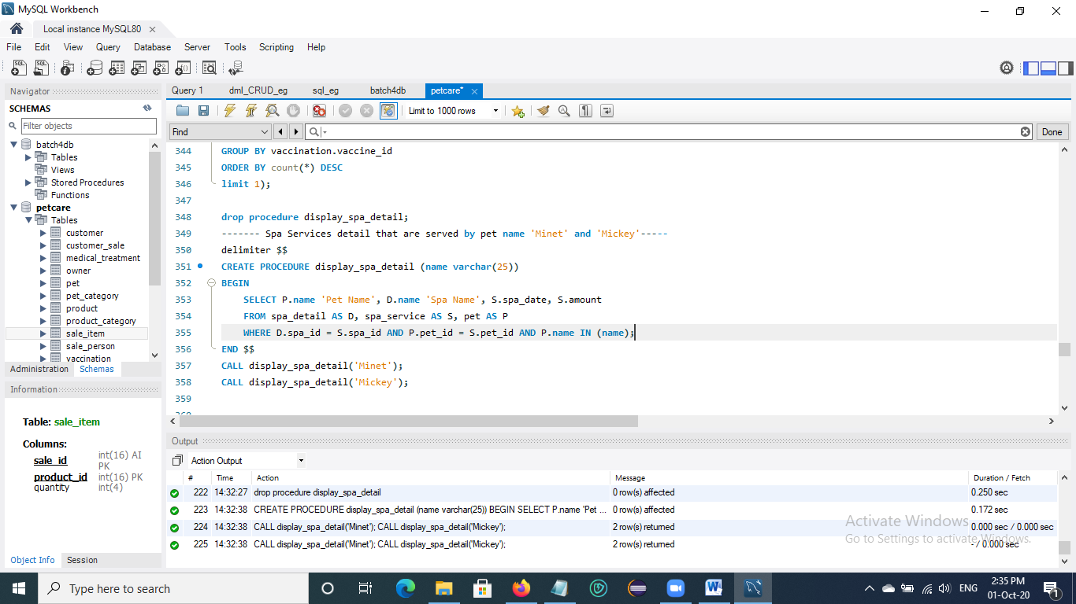

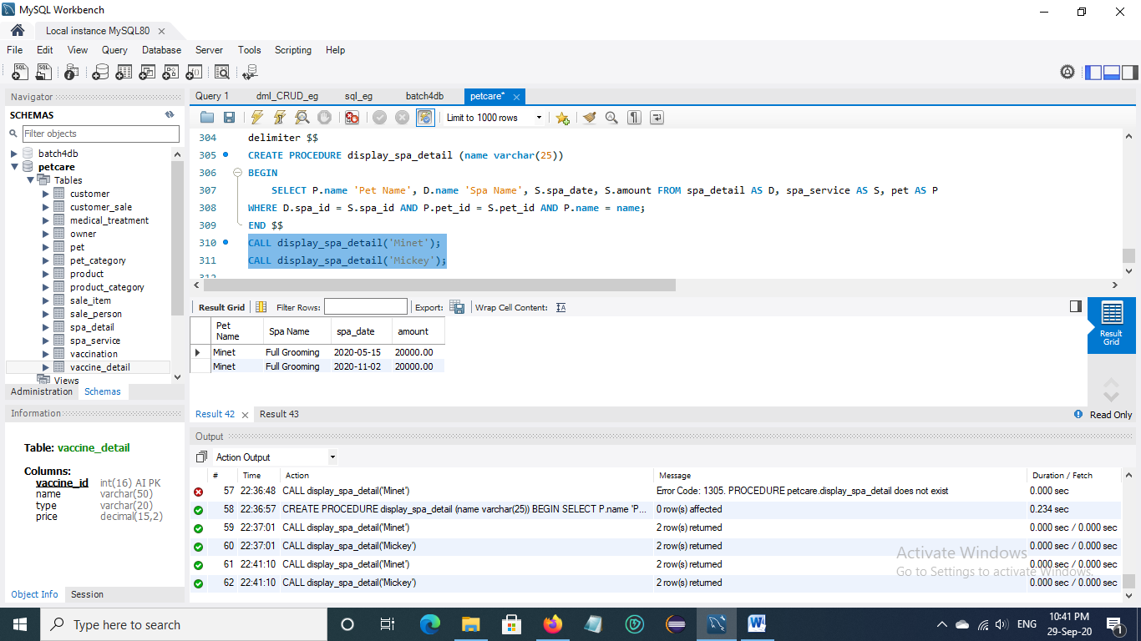

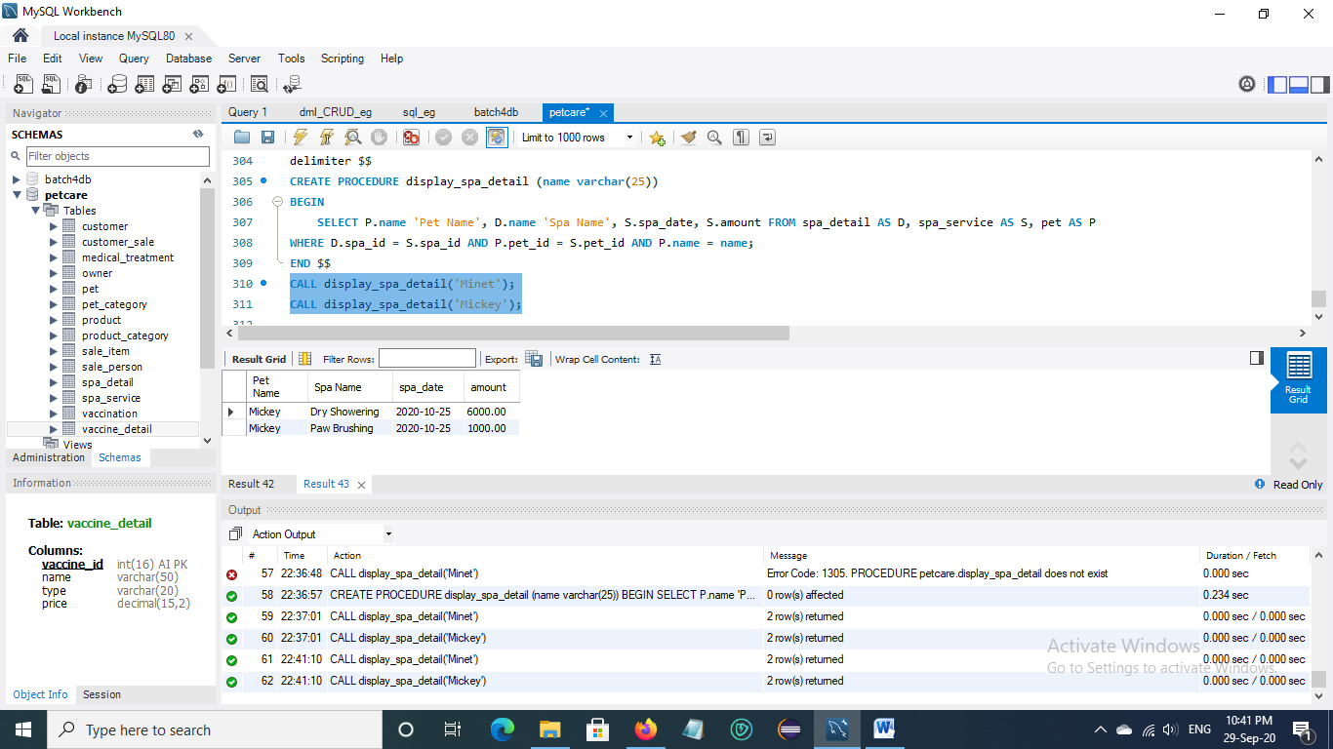

## 3.3 Retrieve daily income in Pet Spa Service

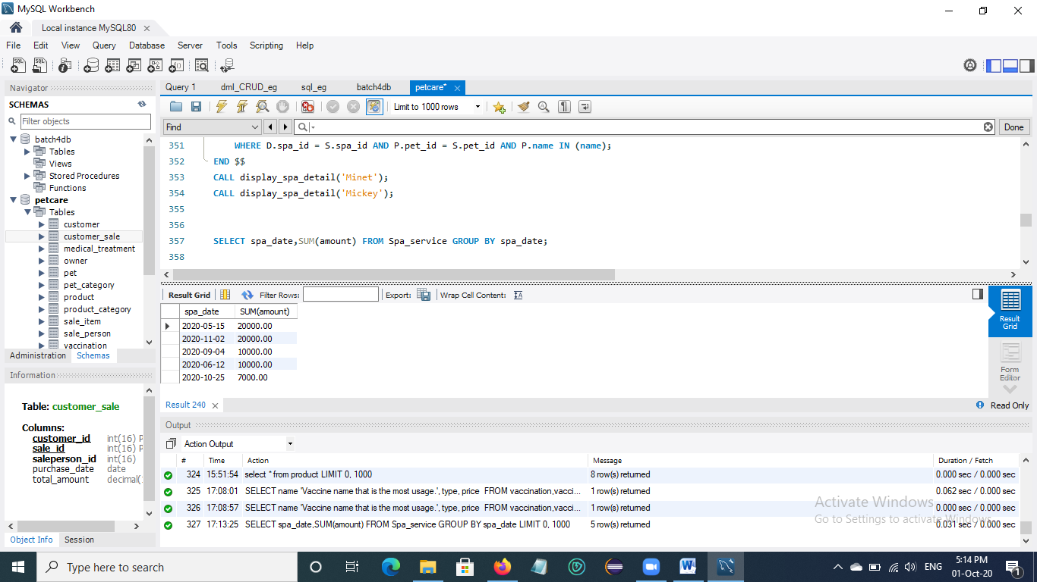

## 3.4 Retrieve total spa service income in June

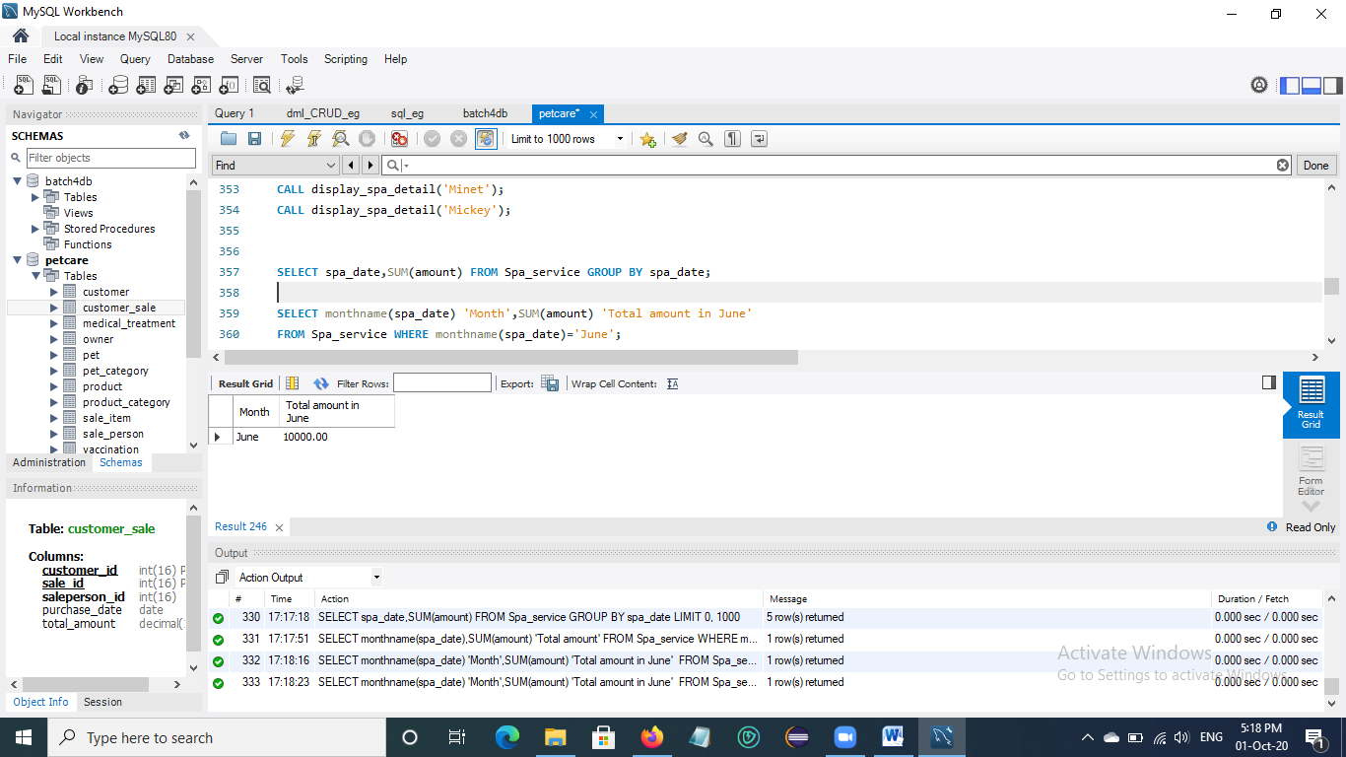

## 3.5 Retrieve total spa service income in 2020

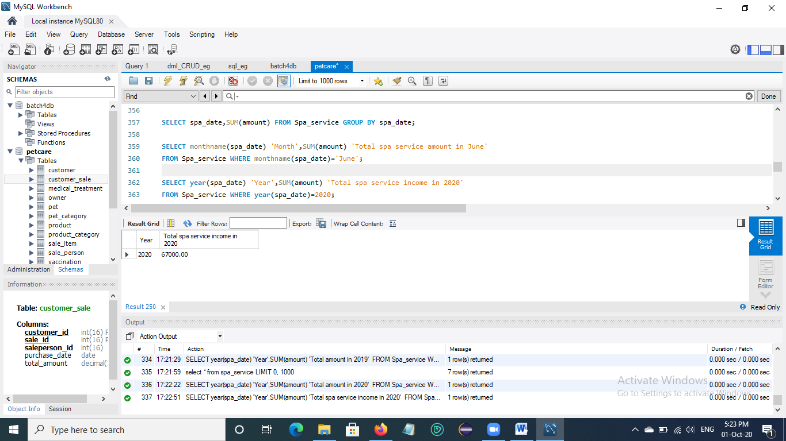

## 3.6 Retrieve all vaccine detail record of pet 'Minet'

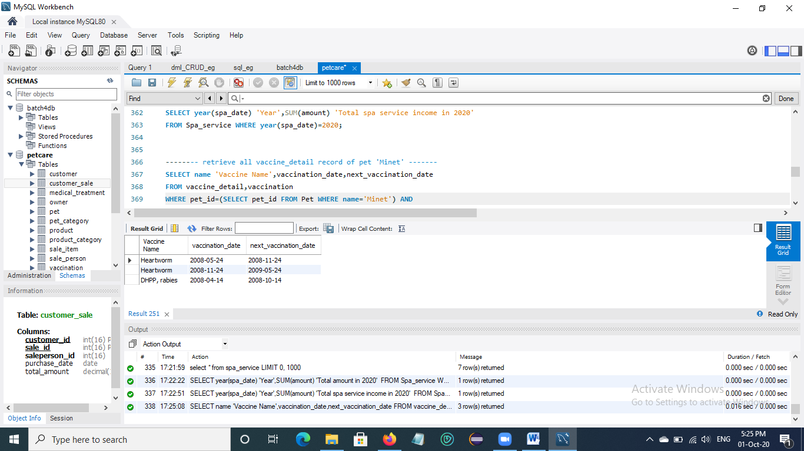

## 3.7 Retrieve all treatment record from start date '2019-06-01' to end date '2019-10-31'

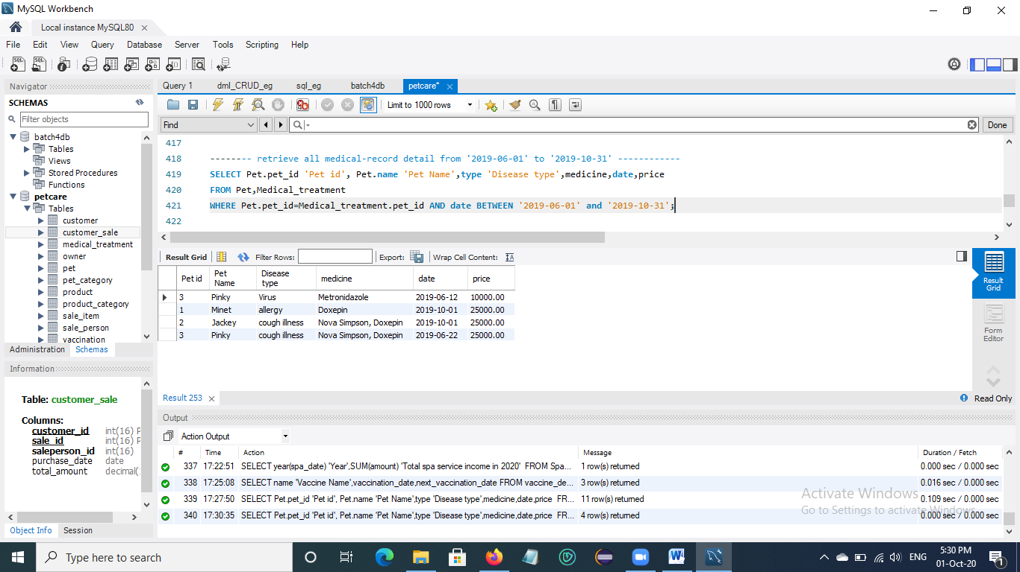

## 3.8 Retrieve medical treatment record detail list of pet clinic with the corresponding pet id and pet name

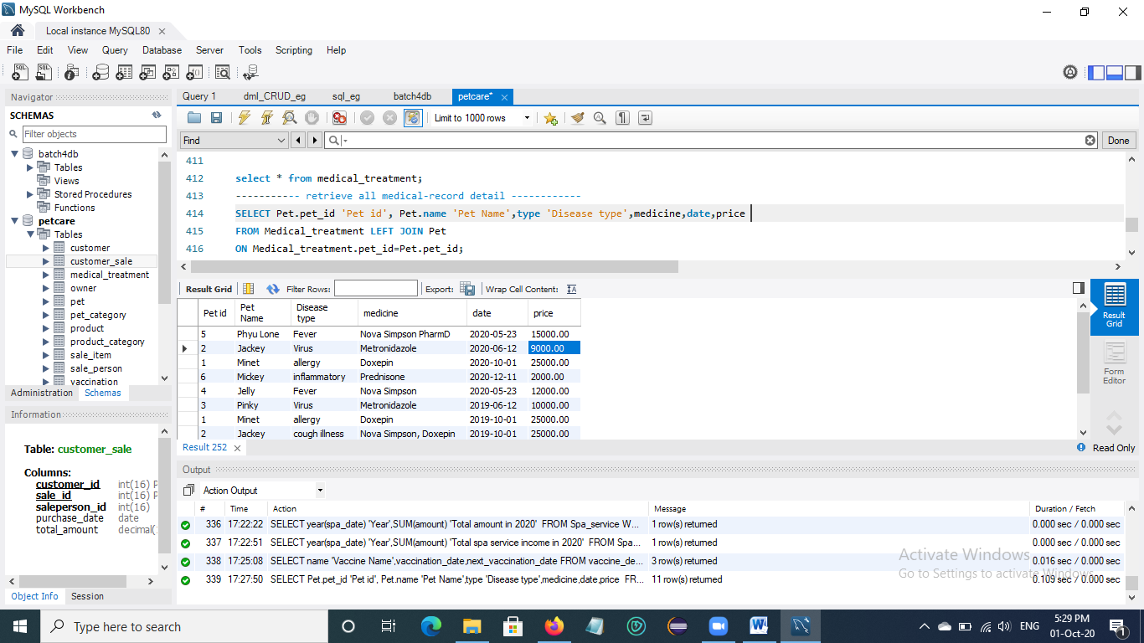

## 3.9 Display monthly income in medical treatment

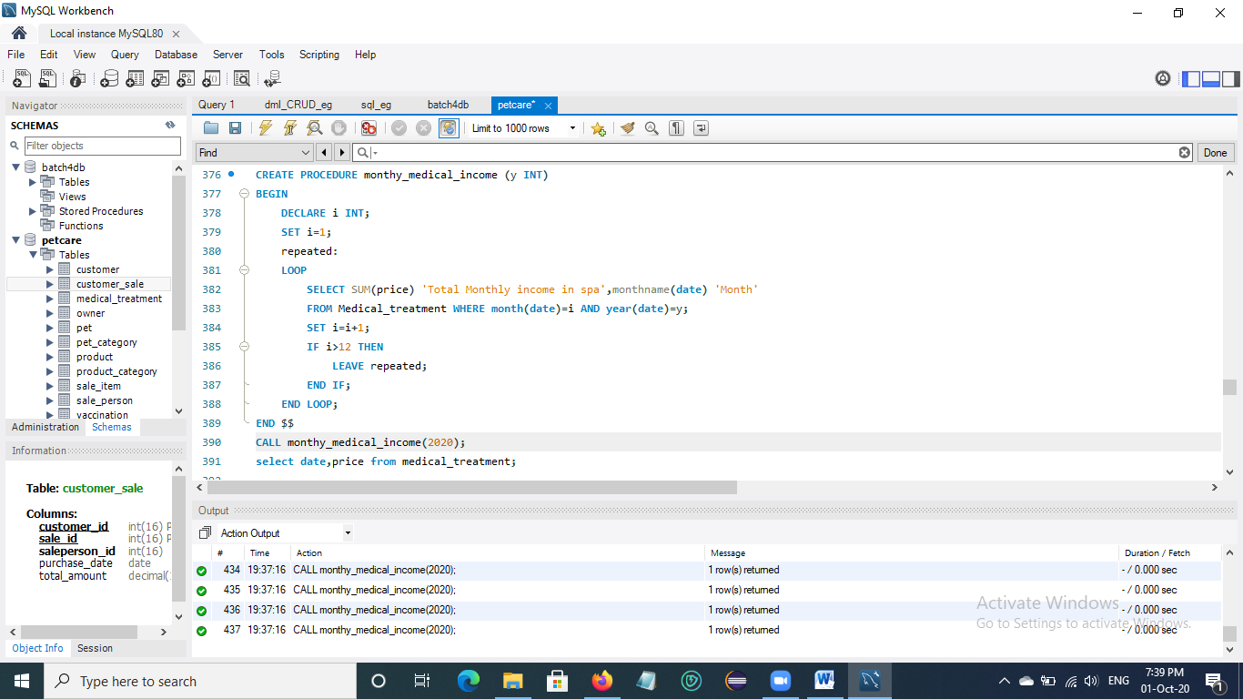

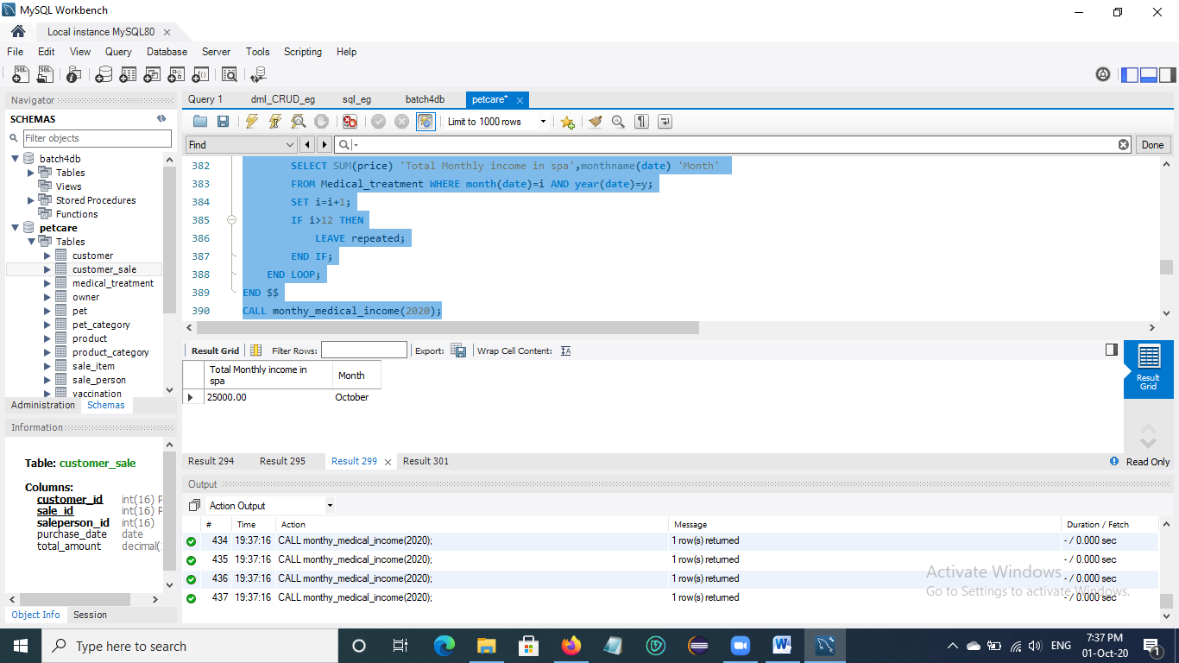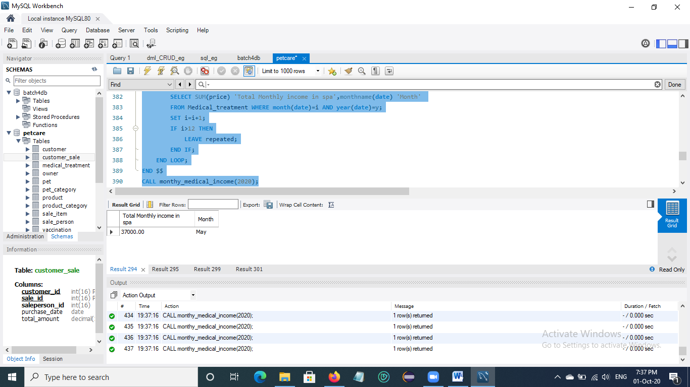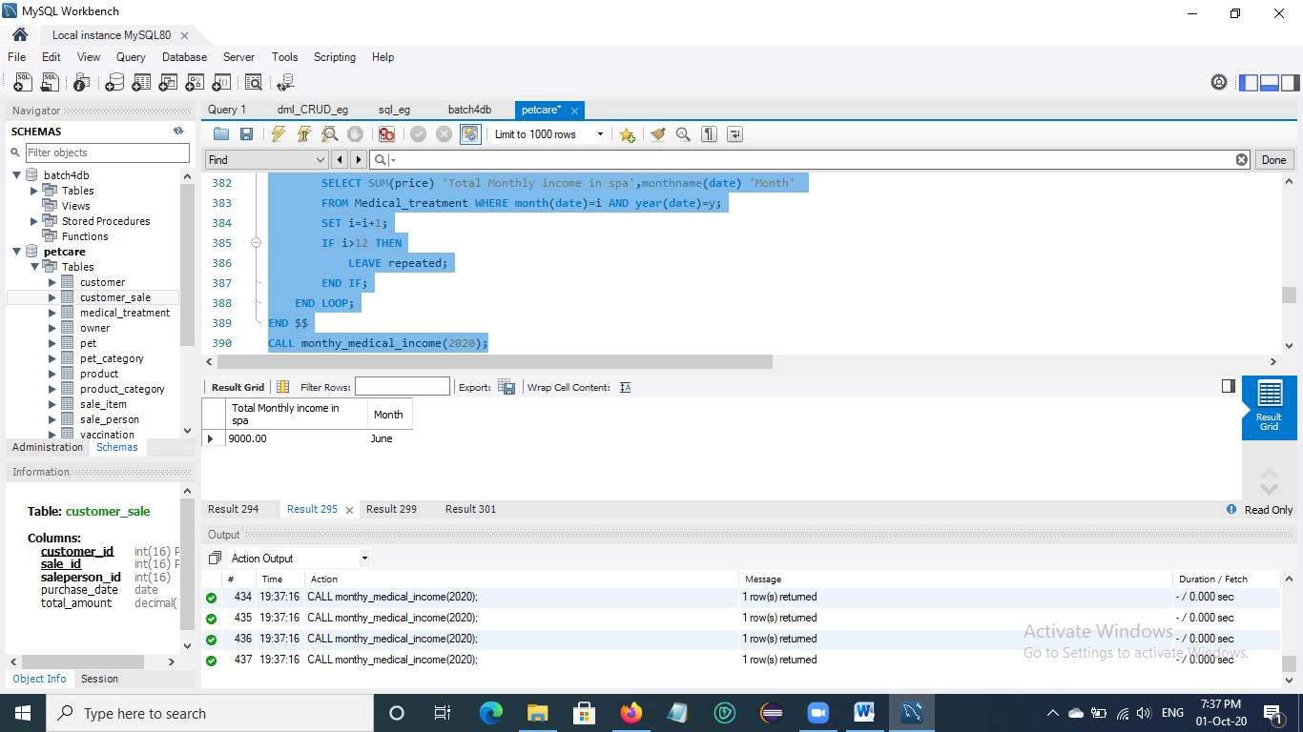 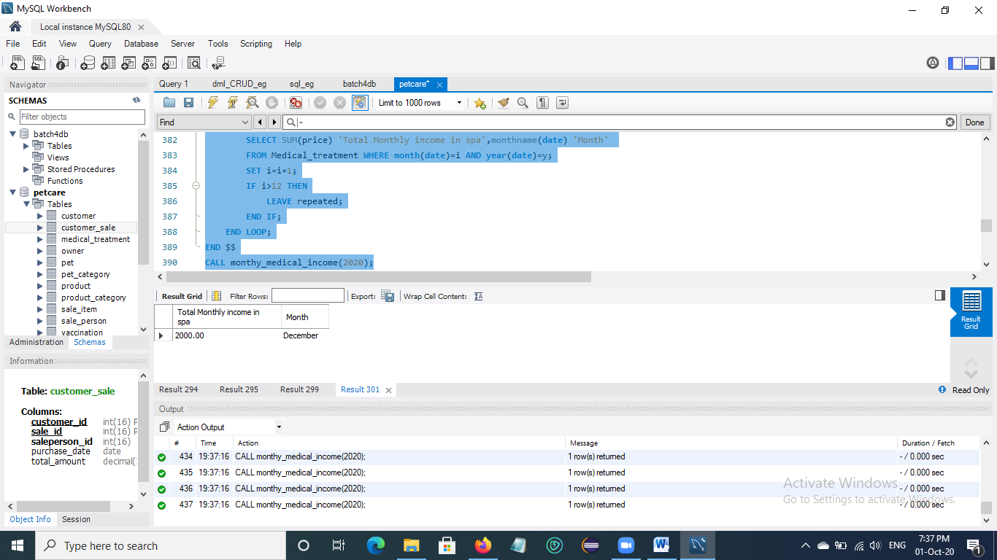

Fig. Monthly income of medical treatment

## 3.10 Display annual income in medical treatment

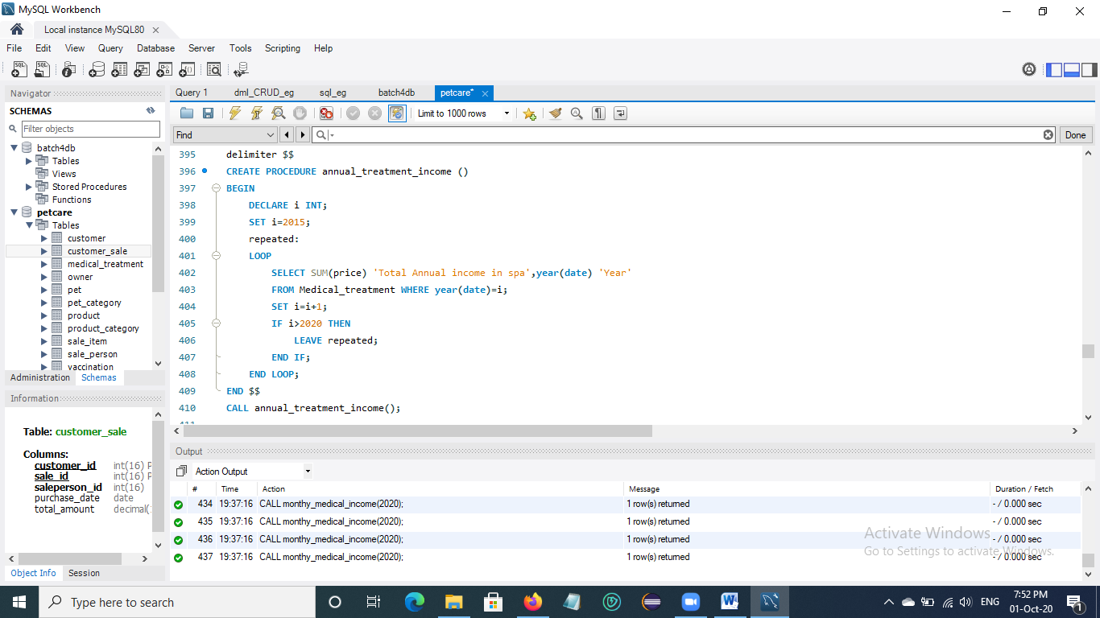

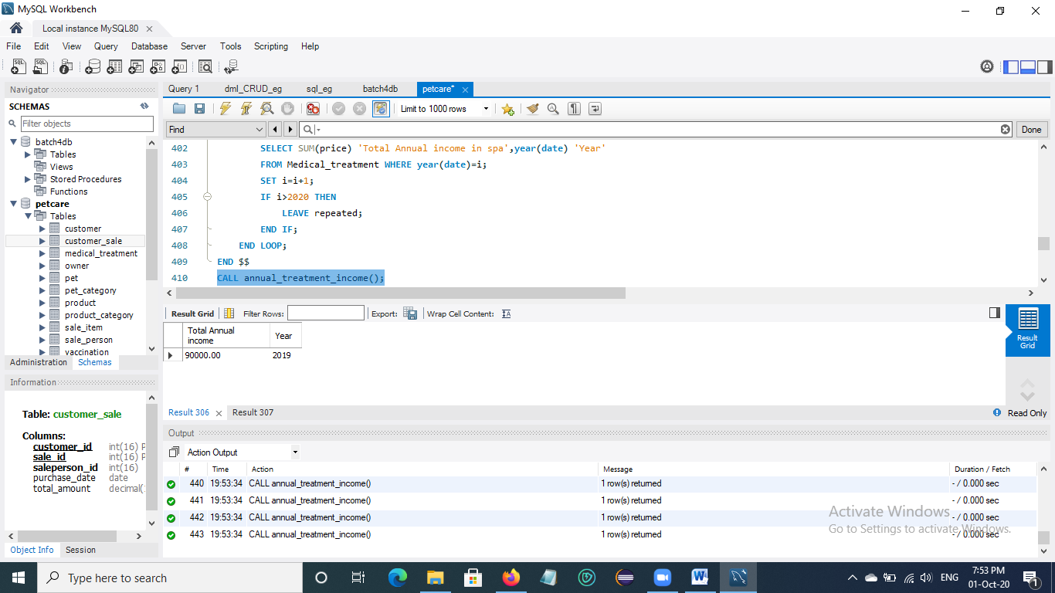 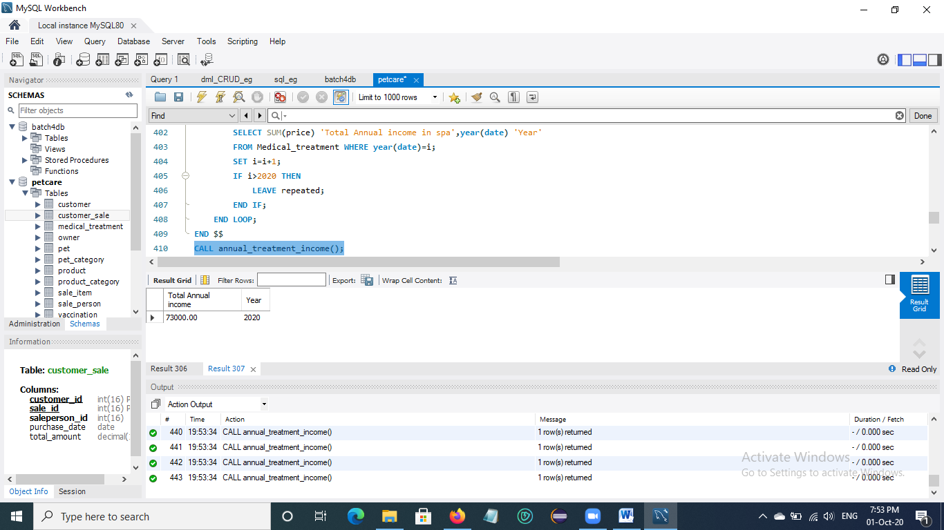

Fig. Annual income of medical treatment

## 3.11 Retrieve top 5 best-selling product List

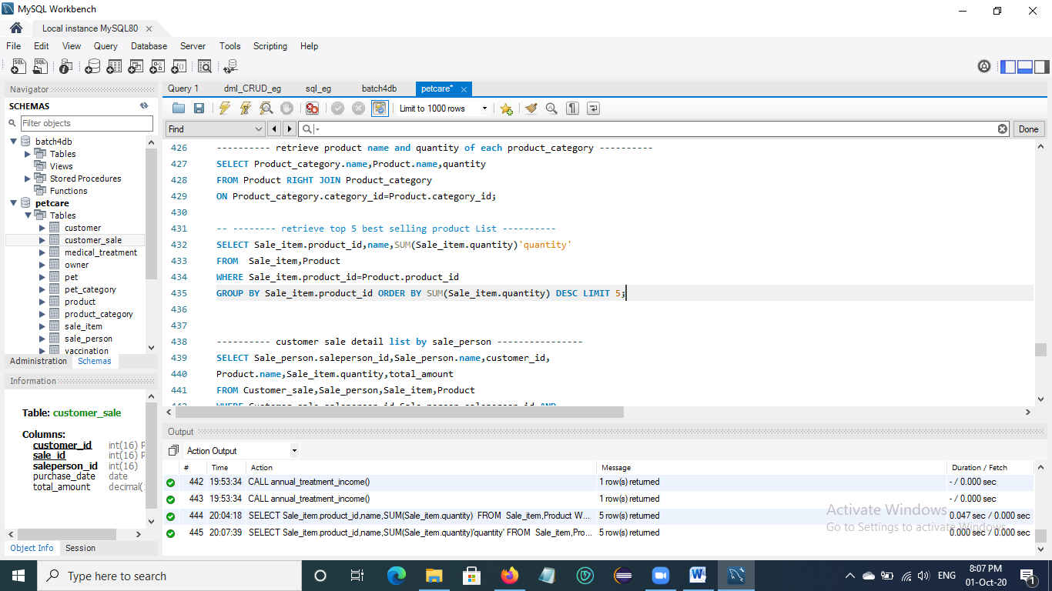

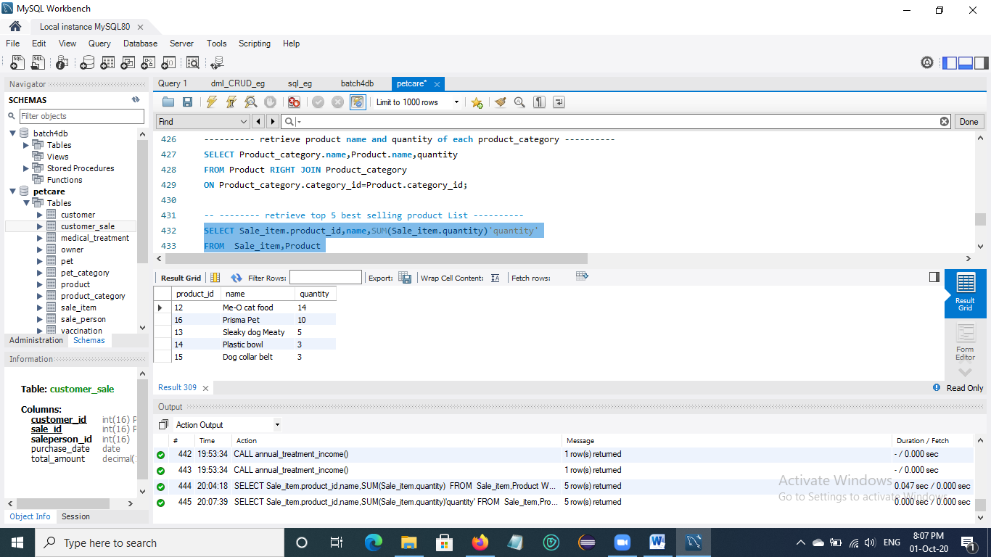

## 3.12 Retrieve product name and quantity in each product category

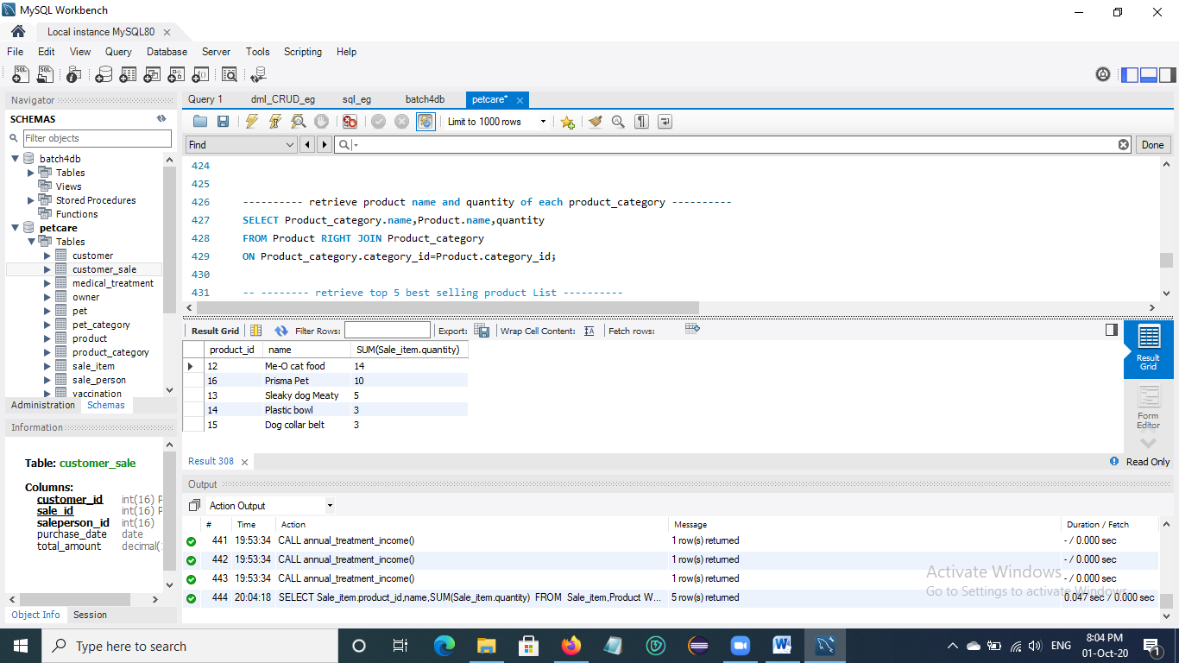

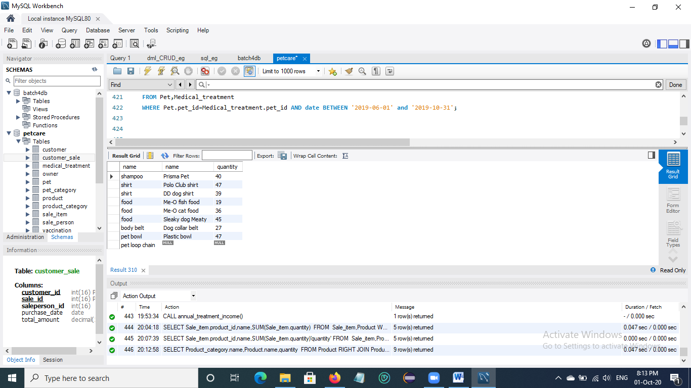

## 3.13 Retrieve product name and quantity in each product category

* + In Sale_person table, there are two people of saleperson named ‘Kyaw Kyaw’.

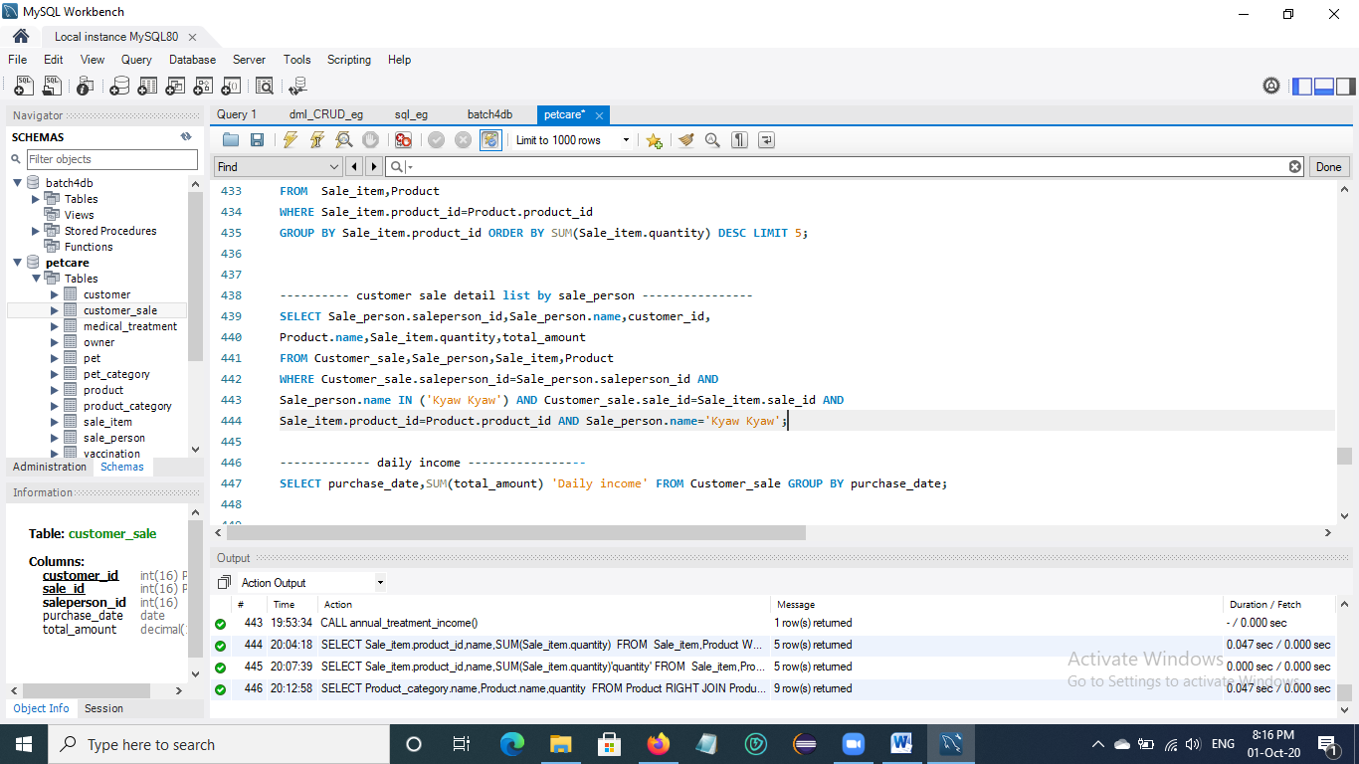

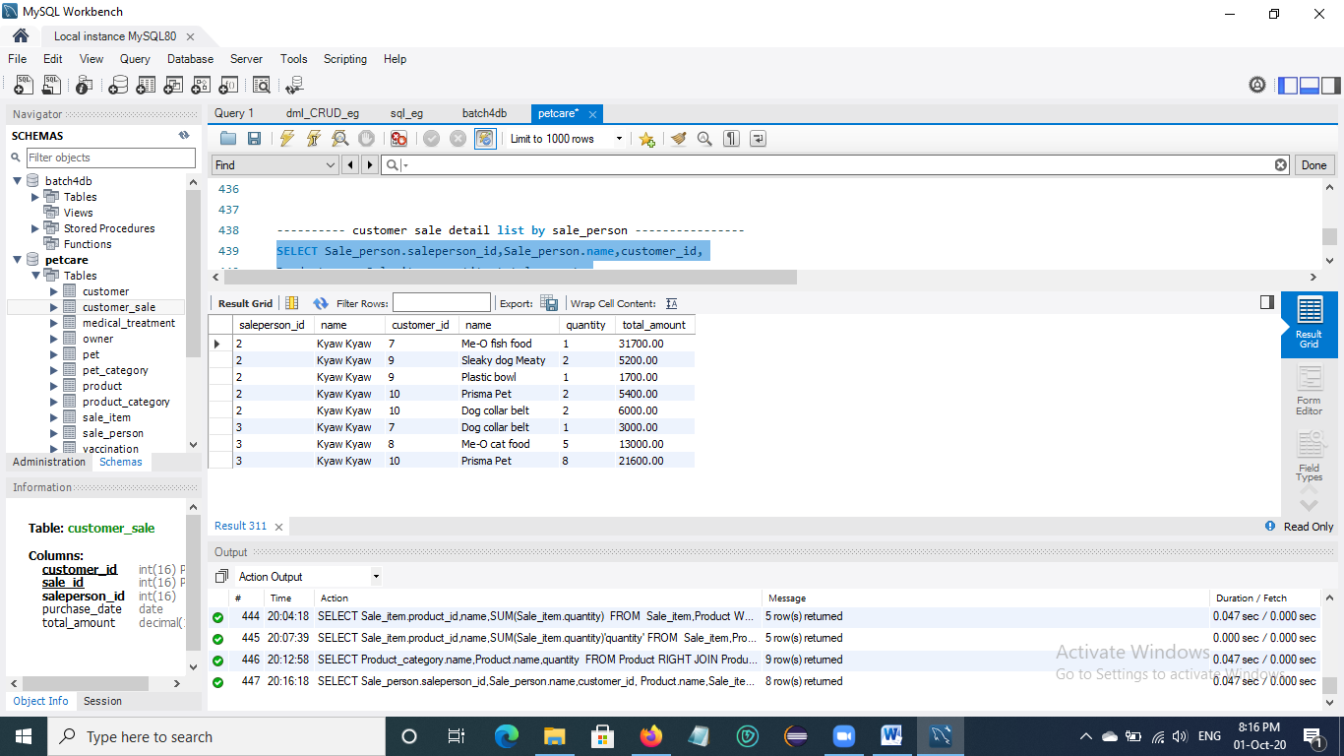

## 3.14 Retrieve daily income of customer sale product

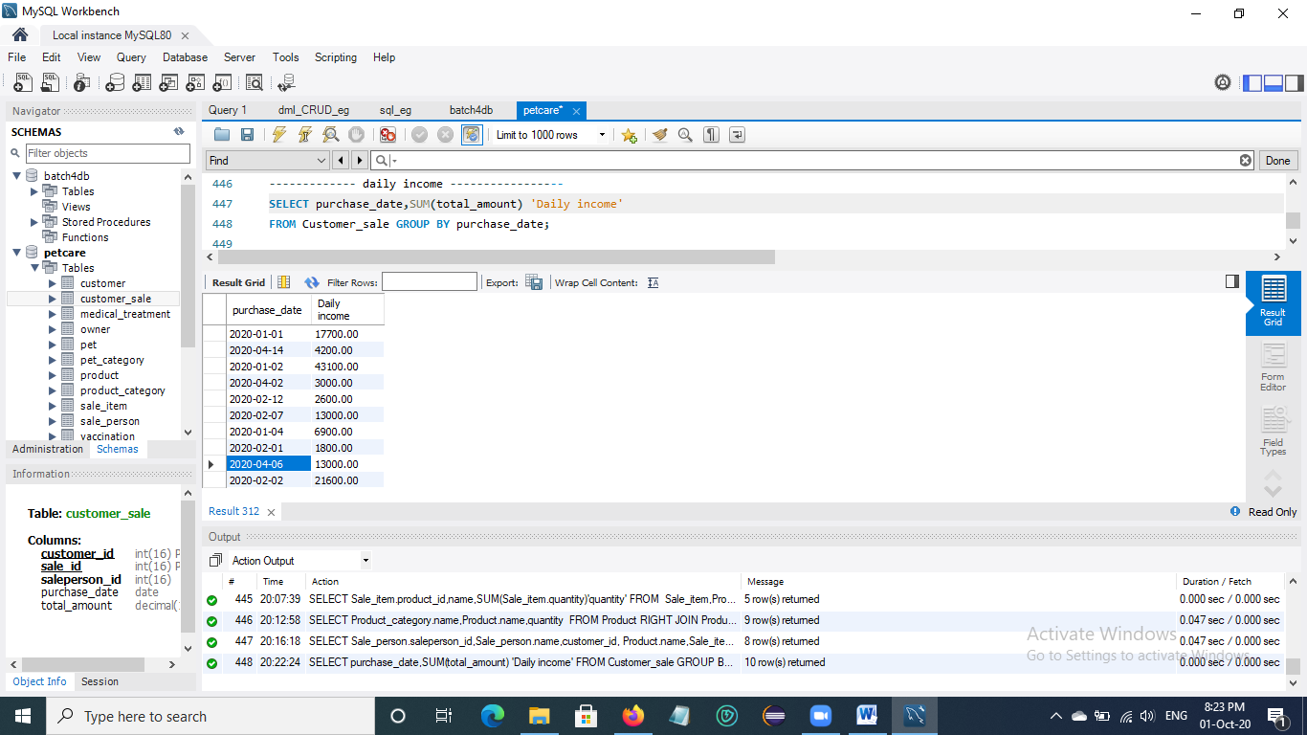

## 3.15 Retrieve the best-selling month in 2020

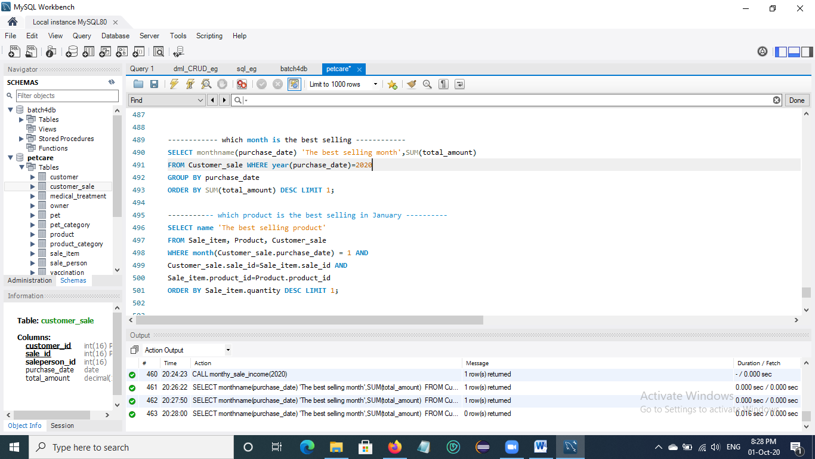

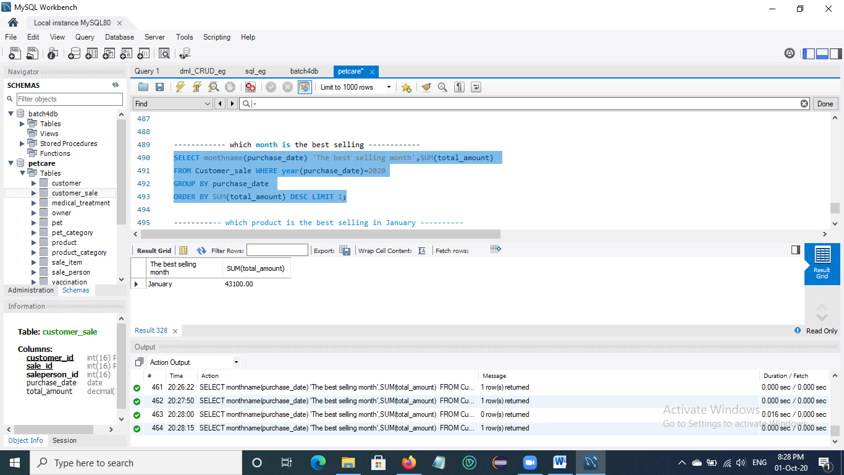

## 3.16 Retrieve the best-selling product in January

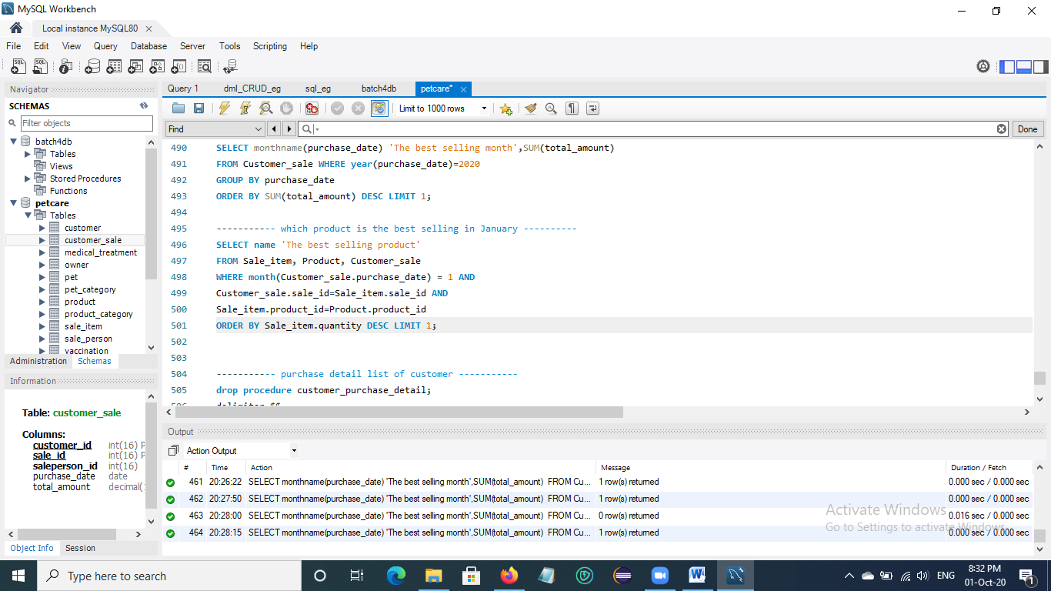

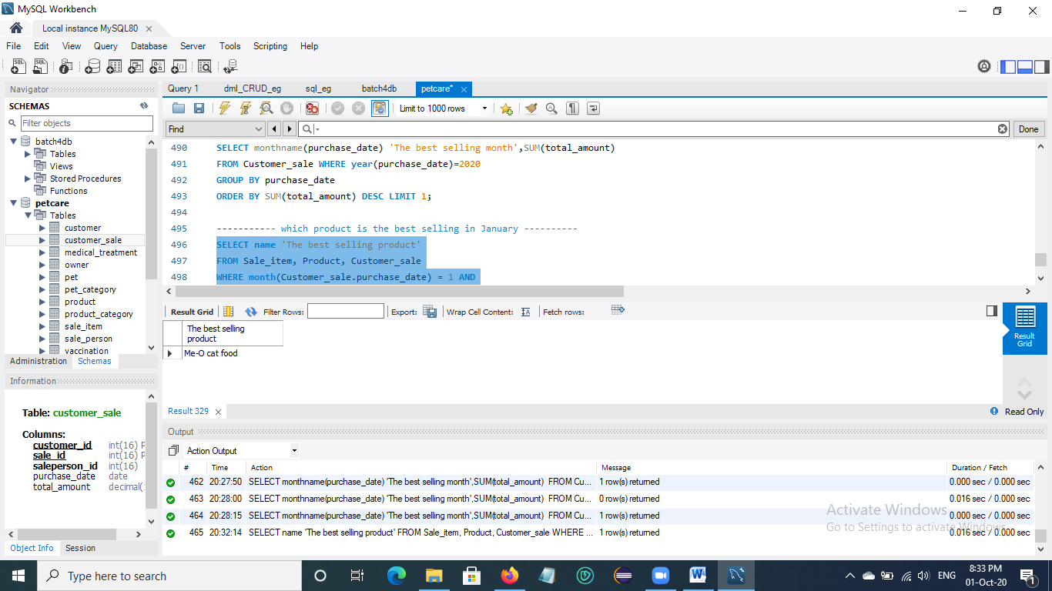

## 3.17 Retrieve product purchase detail of customer id ‘9’ in Customer sale table

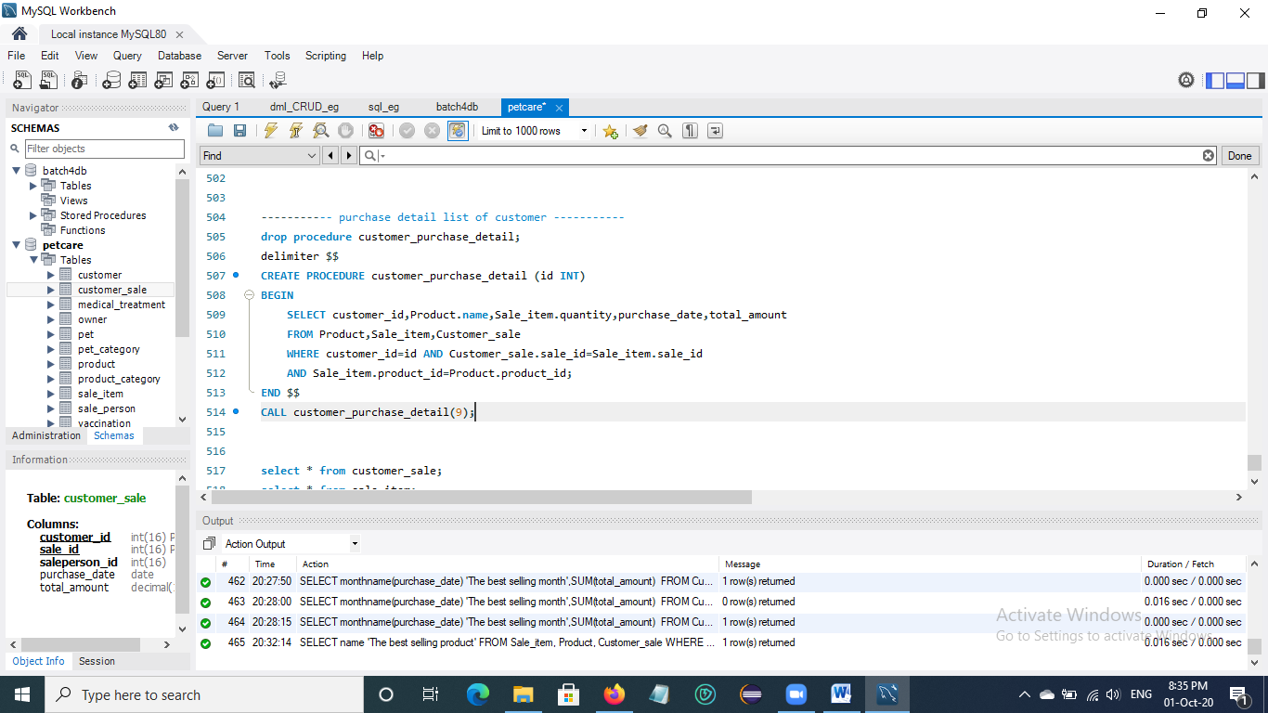

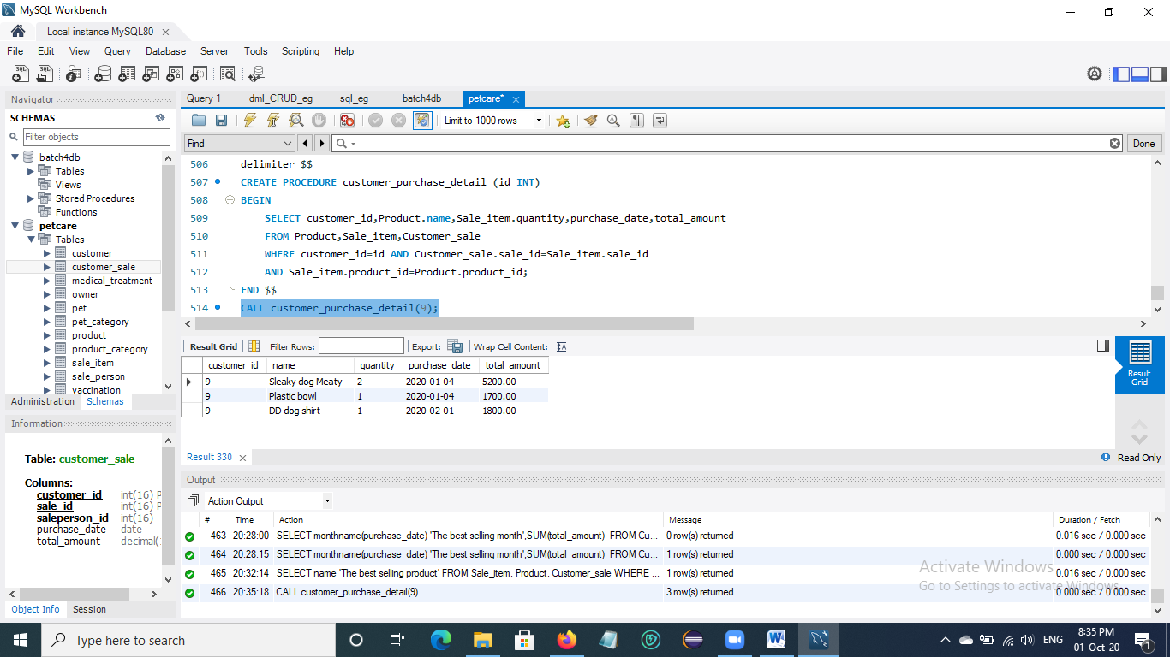

## 3.18 Display monthly income in Customer sale product in 2020

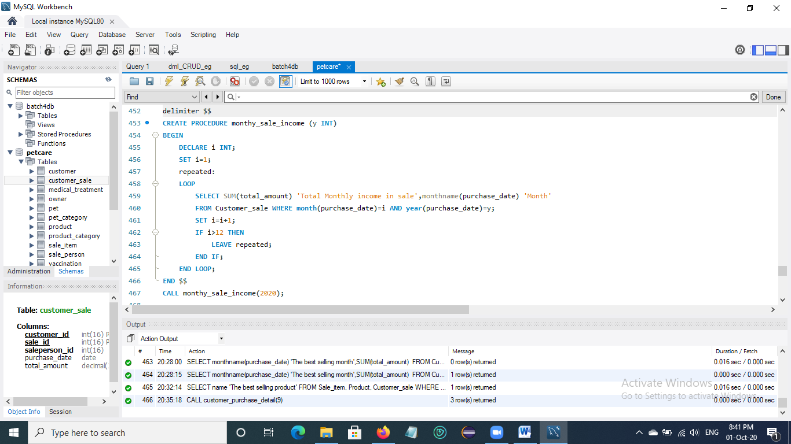

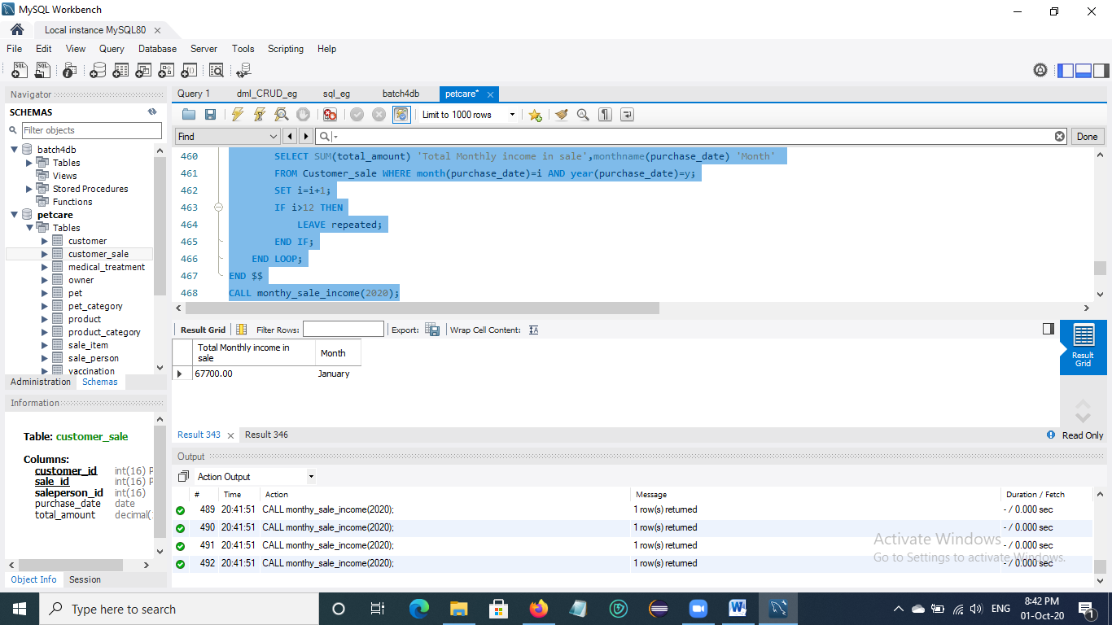 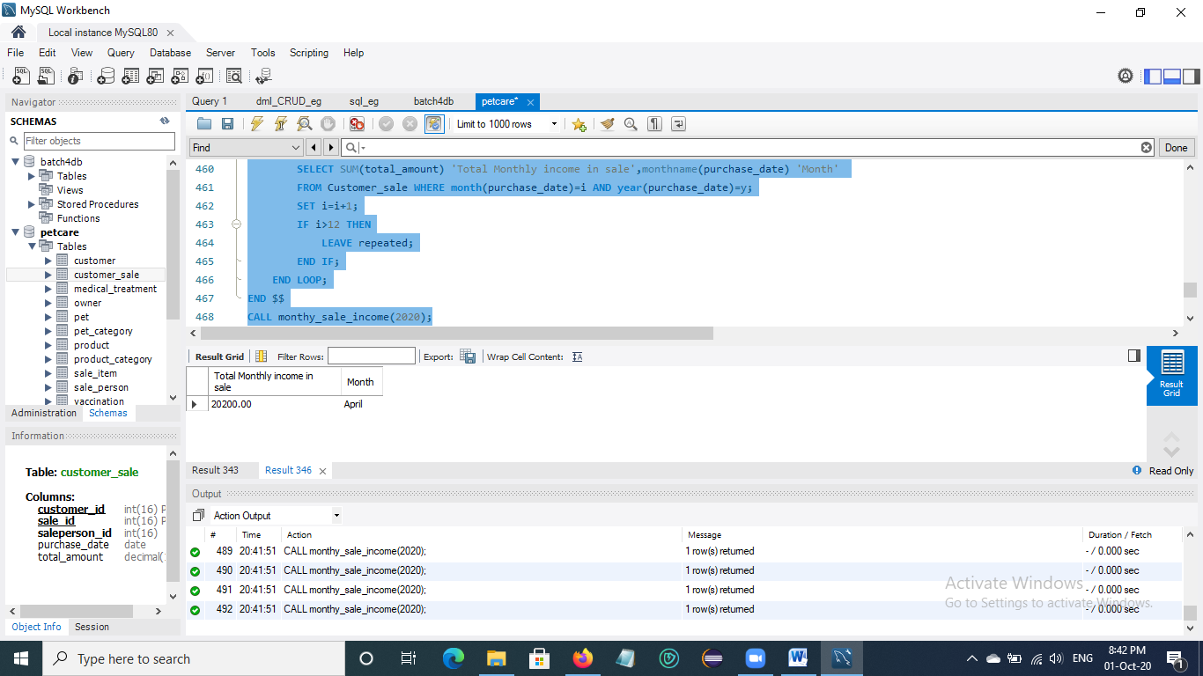

Fig. Monthly income in Customer sale

## 3.19 Display annual income in Customer sale product

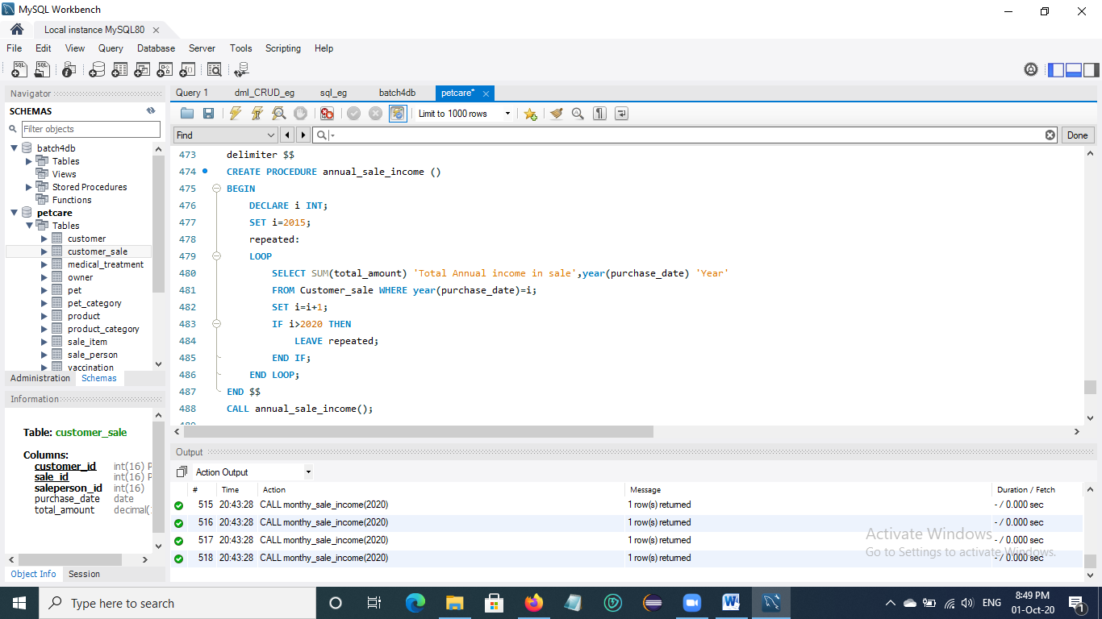

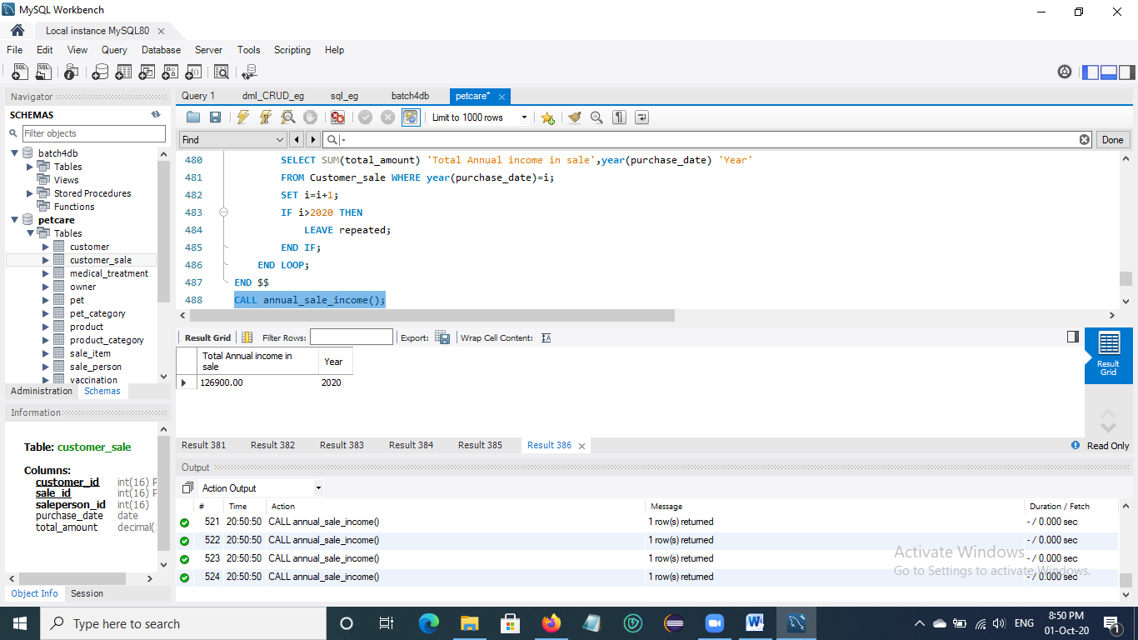

## 3.20 Retrieve pet id and pet name which make spa service price greater than ‘50000 MMK’.

